

**Detecting and Assessing Pollution Events from Wildfires Using Remote Sensing and Meteorological Data**

**A Data Science Approach**

**Sofia Margarida Matias Rodrigues**

Dissertação para a obtenção do Grau de Mestre em

**Ciências dos Dados em Agricultura, Alimentação, Floresta e Ambiente**

Orientador(es): Ana Russo

Célia Gouveia

**(Versão provisória)**

Acknowledgments

Abstrato

Os incêndios florestais contribuem significativamente para a poluição do ar ao libertarem matéria particulada (PM) e gases tóxicos na atmosfera, com as alterações climáticas a preverem um aumento na atividade dos incêndios florestais e na propagação do fumo, agravando os riscos para a saúde. O trabalho a ser desenvolvido será apoiado por um quadro orientado por dados para monitorizar e avaliar a poluição do ar causada por incêndios florestais, uma questão urgente de saúde e ambiental que afeta a população global. O trabalho irá analisar os resultados dos modelos atmosféricos atuais, juntamente com indicadores de deteção remota, como o Fire Radiative Power (FRP) e o Fire Radiative Energy (FRE), combinados com dados meteorológicos e aprendizagem automática, para melhorar a deteção de eventos de poluição. O objetivo é analisar os impactos transfronteiriços das emissões de incêndios florestais, avaliar tecnologias de deteção remota (e.g., MODIS, SEVIRI, Sentinel) no monitoramento de incêndios florestais e examinar métodos de ciência de dados para monitorização ambiental. Na secção de dados e metodologia, será descrita a integração de dados meteorológicos e de deteção remota, com modelos de aprendizagem automática, como Random Forest, XGBoost e Redes Neuronais, usados para classificar eventos de poluição e mapear padrões espaço-temporais do fumo. A validação do modelo será realizada através da comparação dos resultados com eventos históricos extremos de incêndios florestais para verificar a sua precisão. O modelo será, então, avaliado pelo seu desempenho preditivo e fornecerá algumas perceções sobre os padrões de dispersão do fumo dos incêndios florestais, identificando fatores-chave que contribuem para os eventos de poluição. Para concluir o trabalho, serão apresentados os destaques do estudo, demonstrando como os dados de deteção remota e meteorológicos podem melhorar o monitoramento da qualidade do ar e apoiar o planeamento de políticas públicas. Serão propostos trabalhos futuros para melhorar as capacidades de monitoramento em tempo real, integrar fontes de dados adicionais e aplicar as descobertas em quadros ambientais e de saúde mais amplos. Esta pesquisa tem o potencial de informar intervenções estratégicas, reforçando ainda mais as ferramentas de tomada de decisão para gerir a poluição provocada por incêndios florestais.

Palavras-Chave: Fogos, Poluição do Ar, Dados Meteorológicos, Deteção Remota, Aprendizagem Automática

RESUMO PT 1200-1500 PALAVRAS

How to build a good abstract:

Importance of the study

Gap in the existing literature

Objective of the study

Method used to conduct the study

Key findings of the study

Implications of the study

Abstract

Wildfires contribute significantly to air pollution by releasing particulate matter and toxic gases into the atmosphere, posing severe risks to air quality and public health. Fires also have major environmental and societal impacts, affecting ecosystems and global carbon dynamics. Smoke from wildfires exposes populations to hazardous pollutants, while large burned areas degrade biodiversity, disrupt ecological balance, and weaken the ability of landscapes to store carbon. Despite these risks, fire plays an ecological role in some natural systems, helping to reduce underbrush and promote regeneration in fire-adapted species. However, climate change and increasing human pressures are intensifying wildfire frequency, severity, and duration, leading to longer fire seasons and more extreme events. As a result, wildfires are becoming more frequent, destructive, and persistent under rapidly changing climatic conditions.

The work will analyse current atmospheric models outputs coupled with remote sensing indicators, like Fire Radiative Power (FRP) and Fire Radiative Energy (FRE), combined with meteorological data and machine learning to improve pollution event detection. It aims to look upon transboundary impacts of wildfire emissions, evaluate remote sensing technologies (e.g. MODIS, SEVIRI, Sentinel) in wildfire monitoring, and examine data science methods for environmental monitoring.

The work that will be developed will be supported by a data-driven framework to monitor and assess air pollution from wildfires, a pressing health and environmental issue that affects the global population.

For the data and methodology section, it will describe the integration of meteorological and remote sensing data, with machine learning models, such as Random Forest, XGBoost, and Neural Networks, used to classify pollution events and track spatial-temporal patterns of smoke. Model validation will be performed by comparing results with historical extreme wildfire events to verify accuracy. Then the model will be evaluated by its predictive performance and have some insights into wildfire smoke dispersion patterns, identifying key factors contributing to pollution events. To conclude the work, the highlights of the study will be shown, demonstrating how remote sensing and meteorological data can improve air quality monitoring and support policy planning. Future work will be proposed to enhance real-time monitoring capabilities, integrate additional data sources, and apply findings within broader environmental and health frameworks. This research has the potential to inform strategic interventions, further strengthening decision-making tools for managing wildfire-driven pollution.

Key Words: Wildfires, Air Pollution, Meteorological Data, Remote Sensing, Machine Learning

Table of Contents

1.Introduction 11

2.State of the Art 15

3.Data 16

3.1.Study Area 16

3.2.Sources and Datasets 17

3.2.1.Download 18

3.3.Variables 18

3.3.1.Meteorological Data 18

3.3.2.Pollutant Data 19

3.3.3.Wildfire Data 19

3.4.Data Preparation 20

3.4.1.Masks 20

3.4.2.Data Manipulation 21

3.5.Data Understanding 22

3.5.1.Wildfire Data 22

3.5.2.Pollutant Data 25

3.5.2.1.Carbon Monoxide (CO) 25

3.5.2.2.Nitrogen Dioxide (NO2) 26

3.5.2.3.Particulate Matter d < 2.5 μm (PM2.5) 27

3.5.3.Meteorological Data 27

4.Methodology 28

5.Results 40

6.Discussion 41

7.Conclusion 42

References 43

Appendices 46

List of Figures

Figure 1 - Regions defined for the current study within the chosen study area – Portugal, Spain, Italy and Greece 16

Figure 2 - Grid masks created to represent the countries chosen within study area. Resolution 0.75ºx0.75º 20

Figure 3 - Time series of daily sum of FRP values by region from 2003 to 2024 23

Figure 4 - Monthly variability across all years of FRP values (2003-2024) 24

Figure 5 - Total of FRP for each region by year (2003-2024) 24

Figure 6 - Total number of hotspots by year, between 2003-2024, for each region 25

List of Tables

List of Abbreviations

IPMA – Instituto Português do Mar e da Atmosfera

WRF-Chem – Weather Research and Forecasting Model with Chemistry

WRF – Weather Research and Forecasting

SEVIRI – Spinning Enhanced Visible and Infrared Imager

MSG – Meteosat Second Generation

WHO – World Health Organization

WMO – World Meteorological Organization

FRP – Fire Radiative Power

FRE – Fire Radiative Energy

CDS – Climate Data Store

ADS – Atmosphere Data Store

ECMWF – European Centre for Medium-Range Weather Forecasts

ML – Machine Learning

AI – Artificial Intelligence

API – Application Programming Interface

CAMS – Copernicus Atmosphere Monitoring Service

PM – Particulate Matter

IFS – Integrated Forecasting System

EAC4 – ECMWF Atmospheric Composition Reanalysis 4

FIRMS – Fire Information for Resource Management System

MODIS – Moderate Resolution Imaging Spectroradiometer

NetCDF – Network Common Data Form

GADM – Database of Global Administrative Areas

# 1.Introduction

Wildfires are a derivative of a fire that is uncontrolled that spreads across vegetation, often fuelled by dry conditions, strong winds, and abundant combustible material (Knorr, Dentener, Lamarque, Jiang, & Arneth, 2017). They can take large proportions because they usually occur in rural and forested areas, often with difficult access. They also contribute positively to certain natural landscapes by clearing the underbrush and allowing seed release for some species (Knorr, Dentener, Lamarque, Jiang, & Arneth, 2017). Anthropogenic influence largely contributes to the occurrence of extreme episodes, with larger burned areas, which causes a major imbalance in the ecosystems and carbon storage (Knorr, Dentener, Lamarque, Jiang, & Arneth, 2017). Wildfires are increasing its frequency, severity and duration, bringing concerns to the health of those affected by their exposure to a mixture of hazardous air pollutants, like particulate matter (PM2.5 in specific), nitrogen dioxide (NO2) and ozone (O3) (De Sario, Katsouyanni, & Michelozzi, 2013). Wildfires are not isolated events; they are increasingly linked to extreme weather conditions. Droughts, heatwaves, and high winds create the perfect conditions for wildfires to ignite and spread, while climate change continues to amplify these extreme events (Ruffault, et al., 2020). Even though they are aggravated by meteorological extremes, like droughts, heat waves and high winds, wildfires can also be a source that impacts the climate by releasing large amounts of carbon dioxide (CO2) and other greenhouse gases into the atmosphere (World Health Organization, 2025). These gases trap heat in the atmosphere, intensifying the greenhouse effect and contributing to global warming and long-term climate change. In addition, wildfires emit pollutants such as carbon monoxide (CO), nitrogen oxides (NOx), and particulate matter (PM), which deteriorate air quality and can penetrate deep into the lungs and bloodstream, increasing the risk of respiratory and cardiovascular diseases in exposed populations (Rizzo & Rizzo, 2024).

Meteorological extremes or extreme weather events are characterized as rare events “at a particular place and time of year, with unusual characteristics in terms of magnitude, location, timing, or extent” (World Meteorological Organization, 2025). Climate change is one of the main reasons for the increase in the impacts of extremes events that take place, and wildfires are directly linked to that, in a sense that often occur alongside or a result of other climate extremes (e.g. heatwaves, droughts or high winds) (AghaKouchak, et al., 2020). The Mediterranean region is particularly susceptible to weather and climate variability, being more prone to larger occurrences of wildfires, while being directly related to extreme events (Bento, et al., 2023). Beyond fuelling wildfires, extreme weather also worsens air pollution. The combination of prolonged droughts, increased temperatures, and intensified fires releases vast amounts of hazardous pollutants into the atmosphere, affecting air quality and human health on a global scale (Rizzo & Rizzo, 2024).

The World Health Organization (WHO) defines air pollution as a contamination by any chemical, physical or biological agent that changes the natural characteristics of the atmosphere, either indoors or outdoors. Pollution sources are varied, the most common categories being vehicles (that run on combustion motors), industrial facilities and fires (World Health Organization, 2025). Key air pollutants that pose significant public health risks include particulate matter (PM), carbon monoxide (CO), ozone (O3), nitrogen dioxide (NO2), and sulfur dioxide (SO2). Data and studies provided by WHO show that 99% of the global population breathes contaminated air, based on the established guideline limits for each pollutant (World Health Organization, 2025).

That being said, there is a concern that wildfires will become more aggravated over the years, leading to further degradation of air quality. So, it is important to develop studies relating these two topics, air pollution and wildfires, to come up with strategies that promotes interventions and initiatives.

Traditional approaches for studying wildfire air pollution emissions, such as emission inventories, ground-based monitoring, satellite observations, and atmospheric dispersion models, have been essential in estimating pollutant emissions and tracking smoke transport (Li, Zhang, Kondragunta, & Csiszar, 2018). However, these methods come with significant caveats, including uncertainties in emission factors, limited spatial and temporal coverage of ground-based sensors, satellite retrieval errors due to cloud cover, and computational constraints in high-resolution atmospheric modelling (Schneider, Lee, Santos, & Abbatt, 2021). Additionally, atmospheric dispersion models, while commonly used to track wildfire smoke, require heavy computational resources and often exhibit discrepancies between predicted and actual pollution concentrations (Schneider, Lee, Santos, & Abbatt, 2021). Alternatively, remote sensing provides near-real-time data with products, which allow for more effective monitoring of wildfire emissions (Ceamanos, et al., 2023). However, as the availability of large-scale remote sensing and meteorological datasets grows, researchers face increasing challenges in efficiently processing and analysing these vast amounts of data. This presents a key research gap where traditional methods struggle with computational performance and real-time prediction capabilities (Ceamanos, et al., 2023). To address these limitations, the integration of data science approaches is essential, enabling more robust pattern recognition, improved predictive accuracy, and efficient data processing. By leveraging data-driven approaches, this study aims to enhance the understanding of wildfire-induced air pollution using data science resources.

As a subset of Artificial Intelligence (AI), Machine learning (ML) allows systems to learn from data and improve their performance over time without explicit programming, playing a crucial role in extracting insights, detecting patterns, and automating processes across different topics. While all ML is considered AI, not all AI encompasses machine learning. As data generation grows exponentially, ML helps analyse vast and large datasets to uncover trends and make predictions. It includes supervised, unsupervised, semi-supervised, and reinforcement learning, each suited for different tasks. ML uses various algorithms, such as neural networks for complex data, regression for predictions, clustering for grouping similar data, and decision trees for rule-based predictions. By training on data, ML models identify complex relationships, enabling automatic pattern discovery, predictive analysis and large-scale data processing. This makes it crucial to select the right learning approach based on data structure, resources, and application needs (Chen, 2024).

The study will use data from three different sources that will be described in more detail further. Copernicus is the source for two of the different datasets used – the Climate Data Store (CDS) and the Atmosphere Data Store (ADS). Copernicus, the European Union’s Earth observation program, provides free environmental data through satellites, ground sensors, and airborne measurements (Copernicus, 2025). From CDS, the study will use ERA5 hourly data, a reanalysis dataset combining weather models with observations to reconstruct past climate and weather patterns (Copernicus, 2025). ADS will provide CAMS global reanalysis (EAC4) dataset, which is the fourth-generation global reanalysis of atmospheric composition (Copernicus, 2025). Fire Radiative Power (FRP) is one of the variables used to characterize wildfires, it is obtained “from the radiance at the 4-μm band of satellite sensors and represents the instantaneous radiative energy that is released from actively burning fires”. FRP can be used in many ways to provide information about biomass burning, land cover dynamics and hydrological cycles. But for this study, it gives insights about the rate of emissions in relation to the rate of biomass combustion. This allows to estimate trace gas and aerosol emissions or smoke production. The variable can be obtained from multiple polar-orbiting and geostationary satellites and can be obtained through the Moderate Resolution Imaging Spectroradiometer (MODIS) (Li, Zhang, Kondragunta, & Csiszar, 2018). Based on its proportionality to the amount of burned biomass, higher values of FRP indicate more severe fires and in consequence larger levels of smoke production, leading to higher emissions of particulate matter and other pollutants (Durao, Alonso, Russo, & Gouveia, 2024).

**General and specific objectives**

The study has the purpose of detecting and assessing wildfire pollution events by using a combination of remote sensing, atmospheric monitoring data and machine learning approaches, focusing on FRP outputs as indicators of wildfire-induced pollution. In order to achieve the proposed general goal, four objectives will be pursued: 1) identify key indicators from remote sensing and meteorological data that correlates with pollution events due to wildfires – those can be fire activity parameters, atmospheric pollutant concentrations, and meteorological conditions; 2) develop a machine learning-based model to detect pollution events using data from sources already mentioned; 3) analyse the spatial and temporal impacts of wildfire smoke on air quality in affected areas; and finally, 4) analyse the impact of compound extreme events on wildfire-related pollution events.

**Research questions to answer**

# 2.State of the Art

A relevant example of integrating fire activity with air quality analysis is presented by (Moura, et al., 2024), who investigates the impacts of biomass burning in Sinop, a Brazilian city. Their study combines satellite-derived FRP with atmospheric pollutant measurements, meteorological data, and modelling datasets to assess how wildfire events influenced air quality. Statistical analyses revealed that ozone concentrations rose immediately following fires and remained elevated for several days, while particulate matter increased a few days after fire events. FRP showed a strong correlation with ozone levels, confirming its value as an indicator of fire intensity, while temperature exhibited a consistent positive correlation with all pollutants, highlighting its role in pollutant dynamics. These results demonstrate the effectiveness of integrating remote sensing, atmospheric data, and statistical analyses to quantify wildfire-driven pollution events. Although this research focused on the Amazon, where biomass burning is largely associated with deforestation and agriculture, the methodology provides a transferable framework for other regions. Applying similar approaches in Southern and Central Europe, where wildfires are increasingly driven by climate extremes, can improve the understanding of wildfire-pollution interactions and support strategies for air quality management and public health protection.

The article mentioned above shows results for a specific region in Brazil, while this study intends to make the work developed reproducible for other regions of interest or to add more years of data.

# 3.Data

## 3.1.Study Area

The study area selected for this research is located in Southern and Central Europe, defined by the generic geographical boundaries of latitude 34,5ºN to 66ºN and longitude -12ºE to 36ºE, as illustrated in Figure 1. Within this broader area, four specific regions – Portugal, Spain, Italy and Greece – were chosen due to its high susceptibility to wildfires and pollution episodes. These countries frequently experience large-scale fires, are sensitive to atmospheric pollutant accumulation, and are particularly relevant within the context of Mediterranean climate dynamics. This selection provides an ideal framework for analysing the interactions between wildfire activity and pollutant concentrations across diverse yet climate-vulnerable European regions.

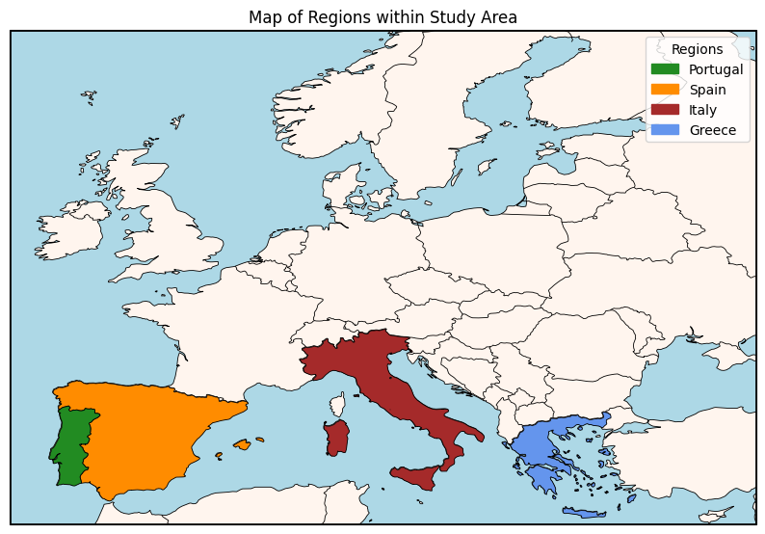

Figure 1 - Regions defined for the current study within the chosen study area – Portugal, Spain, Italy and Greece

While examining the study area, it is impossible to overlook the devastating history of catastrophic wildfires that have marked all chosen countries. Each one has endured tragic fire events that not only results in severe ecological losses but also claimed human lives and destroyed homes, agricultural lands, pastures and other critical infrastructures. Portugal, for instance, experienced one of the deadliest fire seasons in 2017, where 64 people were killed and more than 250 injured, and 30 000 hectares of land burned over 5 days. Other devastating fires were registered in the years of 2024, 2005 and 2003 (Copernicus, 2025). Spain has likewise faced severe wildfire disasters, such as in the summer of 2012, due to a welding negligence and combined with strong winds and high temperatures, more than 30 000 hectares burnt. At the same time this fire was spreading another negligence provoked a second fire in another region that burned 22 500 hectares. Spain had a range of area burned from 11 500 – 47 000 hectares in the years of 2022, 2021, 2012, 2006 and 2003 (Copernicus, 2025). In Italy, based on the burned area provided by (Copernicus, 2025) it is possible to retrieve years 2023, 2021, 2017, 2012 and 2007 as the most area burned with all over 80 000 hectares (and three of them with over 140 000 hectares). Greece, tragically, has witnessed as well repeated large-scale fires in 2023, 2021 and 2007, with more than 100 000 hectares of burned land each, being 2007 the year of most recorded fires and also more area destroyed, like it showed in (Copernicus, 2025). Together, these events illustrate the current importance of keep developing studies in the matter and will be essential years to analyse the influence of pollution events derivative of wildfires.

## 3.2.Sources and Datasets

Copernicus is the European Union’s Earth observation program, and main source of data, that provides free and open data about our planet’s environment, by using a network of satellites, ground-based sensors and airborne measurements (Copernicus, 2025). It delivers real-time information on climate change, land use, oceans, atmospheric conditions and emergency responses to natural disasters like wildfires or floods. Copernicus data can be used to provide relevant information to help service providers, public authorities, international organizations or even for academic and research purposes.

This research utilizes data from three main datastores:

1. Climate Data Store (CDS), which provides the ERA5 reanalysis. ERA5 is defined as the fifth generation European Centre for Medium-Range Weather Forecasts (ECMWF) reanalysis for the global climate and weather, replacing the ERA-Interim reanalysis. A reanalysis is a method used to create long-term, consistent datasets of past atmospheric conditions by combining weather model simulations with real-world observations, in this way it is reconstructing historical climate and weather patterns instead of predicting the future. A key process behind reanalysis is data assimilation, where new observational data is continuously merged with previous model predictions to improve accuracy. This dataset is updated daily, having a delay of about 5 days that is used to prevent providing inaccurate data (Copernicus, 2025).
2. Atmosphere Data Store (ADS), which provides the CAMS (Copernicus Atmosphere Monitoring Service) global reanalysis (EAC4 - ECMWF Atmospheric Composition Reanalysis 4), that is the fourth-generation global reanalysis of atmospheric composition. It combines model data with worldwide observations through data assimilation, creating a consistent, long-term dataset. By integrating new observations every 12 hours, it improves estimates of atmospheric conditions. Unlike real-time forecasts, reanalysis allows for the incorporation of refined historical data, enhancing accuracy over time (Copernicus, 2025).
3. NASA’s Active Fire Data, which provides the FRP dataset. The Fire Information for Resource Management System (FIRMS) is the tool providing near real-time active fire data from the Moderate Resolution Imaging Spectroradiometer (MODIS) carried by Aqua and Terra satellites (NASA, 2025).

### 3.2.1.Download

The process to download data from the two Copernicus databases, ERA5 and CAMS-EAC4, was facilitated by each source providing an Application Programming Interface (API). In each website’s database is possible to select different aspects that it’s needed in the downloadable dataset, such as variables to use, date range, time of observation, geographical area, and data and download format. In the case of CAMS database, it was also possible to determine pressure and model levels. The process of obtaining data could be done using the website directly of having the provided script run locally. The API essentially works as a set of rules that specify how one can request data from a database, establishing a relation between a client and a server. In a more common way can be used in “log in”, navigation apps or processing a card payment, uses of the daily basis (IBM, 2025).

Because these two databases have different time ranges, from the ERA5 database it was downloaded the years 1979 to 2024 for every month, day and time available, for all the variables needed and the generic study area. The data retrieved from CAMS-EAC4 was done in two separate API’s, where it is determined by single-level and multi-level. In the latter it was opted to download with a pressure level of 1000 hPa, to represent values from the surface. The downloaded years for this dataset was 2003-2024 and also for every time available. All data files were provided in a zip file that contained its respective Network Common Data Form (NetCDF) files. Using this kind of format allows to store large and multidimensional datasets on a very easy-access way.

Data on wildfires was extracted from FIRMS, by downloading the required data creating an online request, very similar to the API method mentioned above. It consisted in selecting a custom region with the same coordinates used to define the study area. The fire source was MODIS (both Aqua and Terra spacecrafts) for the first data available (November 2000) to end of 2024 in a .csv (comma separated values) format. The request was approved and sent to via email.

In the following analysis to the data and to be able to correlate every data downloaded, it was decided to use only the period of time that was identical throughout the data (2003-2024).

## 3.3.Variables

### 3.3.1.Meteorological Data

The ERA5 dataset has a global coverage of gridded data with a horizontal resolution of 0.25ºx0.25º, it equivales to approximately 28 km. It provides data from 1940 to present and has a temporal resolution of 1 hour (Copernicus, 2025). It contains many variables, but for this study, these are the ones that are going to be used:

* 10m u-component of wind (m.s-1) – horizontal speed of air moving towards the east, at 10 meters above the surface of the Earth.
* 10m v-component of wind (m.s-1) – horizontal speed of air moving towards the north, at 10 meters above the surface of the Earth.
* 2m temperature (K) – air temperature at 2 meters above the surface of land, sea or inland waters.
* Total precipitation (m) – this variable contains the accumulated liquid and frozen water that falls to the Earth’s surface. It sums the large-scale precipitation and convective precipitation. The cloud scheme in the ECMWF, Integrated Forecasting System (IFS), represents the formation and dissipation of clouds and large-scale precipitation. The convective precipitation is generated by the convection scheme in the IFS. Total precipitation parameter does not include other forms of water, like fog, dew or precipitation that evaporates in the atmosphere.

### 3.3.2.Pollutant Data

The CAMS-EAC4 dataset has a global coverage with a gridded horizontal resolution of 0.75ºx0.75º, equivalent to approximately 80 km. It has a temporal coverage of 2003 to 2024, where this dataset is updated twice a year with 4 to 6 month delay. Its temporal resolution is of 3 hours and has a vertical resolution of 60 models and different pressure levels (hPa) (Copernicus, 2025). The variables retrieved from this dataset were divided into 2 groups:

* Single-level:
  + Particulate matter d < 2.5 μm (PM2.5) (kg.m-3)
  + Particulate matter d < 10 μm (PM10) (kg.m-3)
* Multi-level, where it was specified to retrieve data from pressure level 1000 hPa, that correspond to the Earth’s surface:
  + Carbon monoxide (CO) (kg.kg-1)
  + Nitrogen dioxide (NO2) (kg.kg-1)
  + Nitrogen monoxide (NO) (kg.kg-1)

### 3.3.3.Wildfire Data

The FRP dataset represents the radiative energy released by active fires, derived from satellite sensors. The point dataset contains the respective coordinates of the observed energy, contains the date and time of the registration, the value of the FRP in MW, among others but only this will be relevant to the research.

Appendix 1

## 3.4.Data Preparation

### 3.4.1.Masks

After defining the specific regions of interest to be included in the analysis, the next step involved generating geographic masks that represented each region on the chosen grid. Using the spatial resolution of the CAMS dataset (0,75ºx0,75º), a procedure was developed to obtain a polygon grid cell from the original shapefiles, in EPSG:4326 (WGS84) from the [Dataset of Global Administrative Areas (GADM) official website](https://gadm.org/download_country.html). Because Portugal and Spain share a common border, grid cells intersecting both countries were assigned to the country containing the largest area of that cell. This was done to ensure that the spatial attribution corresponded to the most representative territory, particularly in regions where the most intense fires tend to occur close to national boundaries, seen in appendix 1. For both Italy and Greece no overlapping situation occurs so the standard procedure to create the masks were maintained. The resulting masks, depicted in Figure 2, were created to enable the later assessment of wildfire influence on pollutant concentrations. Later in development of results it was then decided to produce results for Portugal and Spain together, calling it Iberia region, this way it is possible to have a better understanding of the influence of fires in said region.

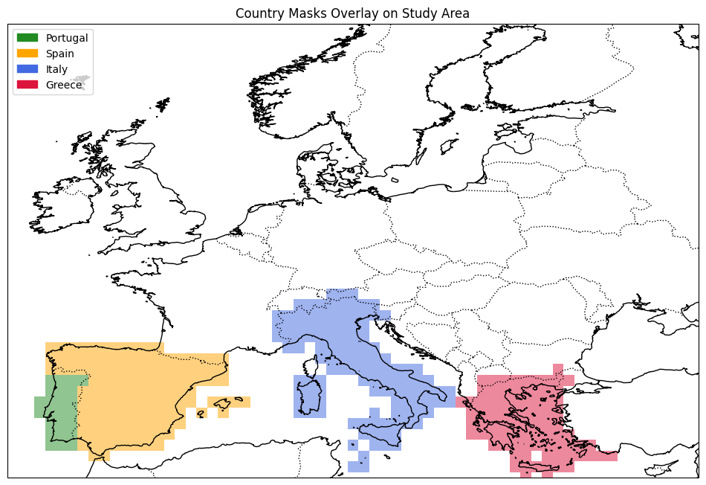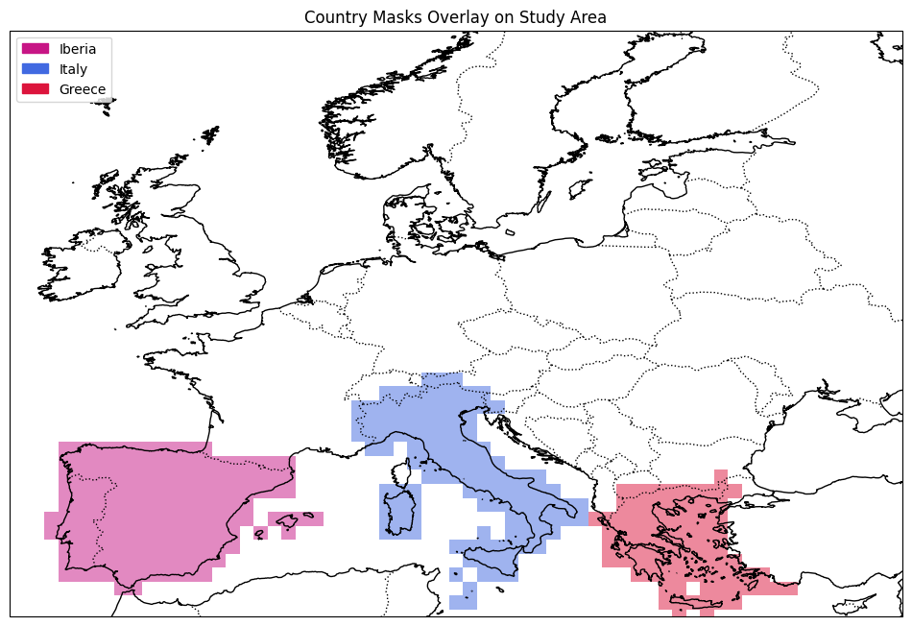

Figure 2 - Grid masks created to represent the countries chosen within study area. Resolution 0.75ºx0.75º

### 3.4.2.Data Manipulation

Apart from the downloading, several manipulation procedures were required. There was the necessity to convert coordinates from 0º to 360º to -180º to 180 and cropping the area of data that was contained in some files (instead of having data for the entire globe, have only for the study area established). For each of these steps new files were created, guaranteeing the user to go back one step instead of the entire workflow, if needed.

Unit conversion was performed to the pollutants data to match the WHO air quality guidelines recommended levels, available at (WHO, 2025). Scripts were created to make the following conversions across different variables:

* For multi-level variables (CO, NO and NO2): pollutant’s concentration multiplied by pressure and divided by the multiplication of R and temperature, where pressure = 1e5 Pa (equal to 1000 hPa), R = 287.0500676 (J/kg.K) and t corresponds to the respective temperature downloaded from CAMS dataset in Kelvin. The equation used is the following $\frac{\left[Pollutant\right] * pressure}{(R * t)}$
  + Carbon monoxide (kg.kg-1) to mg/m3 and then to μg/m3 by multiplying 1000
  + Nitrogen dioxide (kg.kg-1) to μg/m3
  + Nitrogen monoxide (kg.kg-1) to μg/m3
* For single-level variables (PM2.5 and PM10): multiply values by 1e9
  + Particulate matter d < 2.5 μm (PM2.5) (kg.m-3) to μg/m3
  + Particulate matter d < 10 μm (PM10) (kg.m-3) to μg/m3

Temperature data was converted from Kelvin to Celsius, subtracting 273.15 to the value of temperature for every grid point.

Precipitation was converted from meters to millimetres, multiplying 1000. This step was only applied when using this data for plotting. To better make use of precipitation data, said data should be converted to millimetres, so a script should be created for it and update the scripts that make these conversions when plotting.

Wind speed and direction were obtained from u = 10m u-component of wind (m.s-1) and v = 10m v-component of wind (m.s-1) from ERA5, using the respective formulas:

* Wind speed = $\sqrt{u^{2}+v^{2}}$
* Wind direction = $\left(180°+\frac{180°}{π}atan2\left(u10,v10\right)\right)mod 360°$

In final preparations, scripts were created to obtain daily, monthly and yearly statistics to allow for the necessary analysis. Only daily statistics (mean, median, standard deviation, minimum and maximum) and long-term climatology-like averages were used extensively throughout the pipeline.

Because meteorological data, temperature, precipitation and wind, has a different horizontal resolution, before calculating the statistics needed, it was necessary to regrid the datasets. This was achieved by making a note of when to start and end this regrid (study area), then in sets of 3 pixels (forming this way a larger grid of 9 pixels each), the code developed was able to go from 0.25 to 0.75 performing the statistical analysis necessary, matching the pollutant’s horizontal resolution.

In the fire dataset it uses points, with respective latitude and longitude, to mark the exact location where the satellites registered FRP. To be able to use all variables in the same data format, a step was taken to convert a point dataset to a grid dataset. Before that all points that contained FRP equal or below 50 MW were removed, to better represent more intense fires. The grid parameters used to define the new dataset were identical to what was necessary – resolution of 0.75x0.75, like the pollutants and the area defined was the study area. For each pixel created the script performed a group of statistics (sum, mean, median, max, min, std, and count of points) of the points that intersected each square/pixel.

Figure 3 – reorder

## 3.5.Data Understanding

To investigate the temporal dynamics of wildfires and meteorological variables and their potential influence on air quality, time series analysis were conducted for both FRP and atmospheric pollutant concentrations. These plots allow to better understand trends, seasonal patterns and interannual variability across the respective data.

### 3.5.1.Wildfire Data

The raw FRP dataset contains fires of low intensity (≤ 50 MW), such as minor agricultural fires – prescribed burns, those were removed because they don’t impose significant alterations in pollutants concentration levels.

In Figure 3, it is represented the time series of the daily sum of FRP values, in MW, across the years of the dataset for each region. Higher values indicate larger fires occurred in those years.

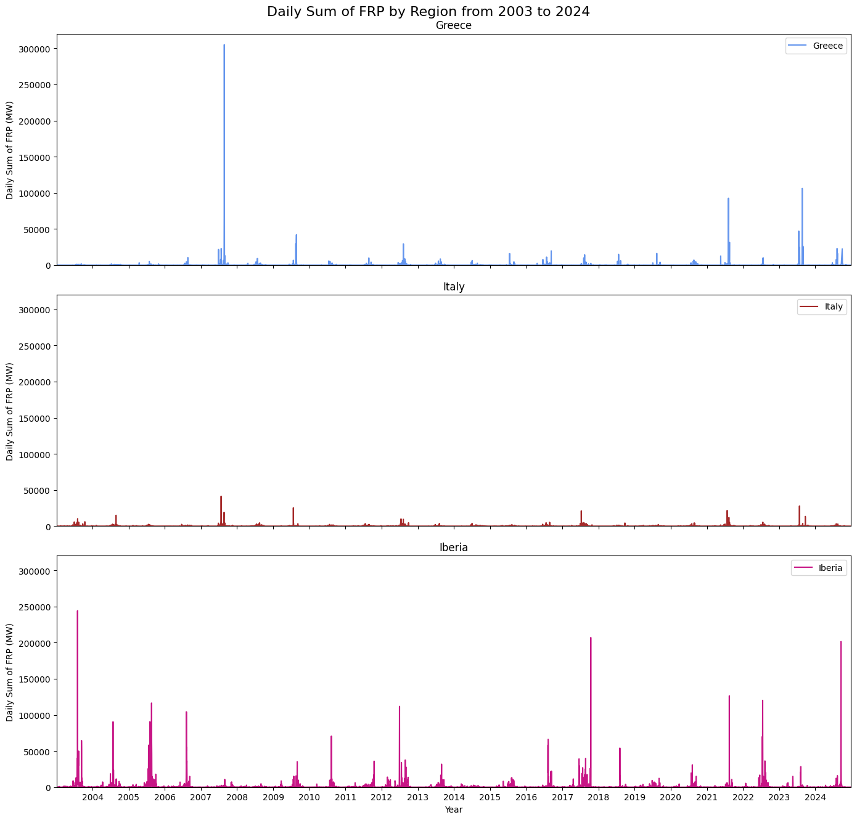

Figure 3 - Time series of daily sum of FRP values by region from 2003 to 2024

In Figure 4, it shows the monthly variability across all years, and as expected the northern hemisphere summer months (July, August and September) show fire predominance.

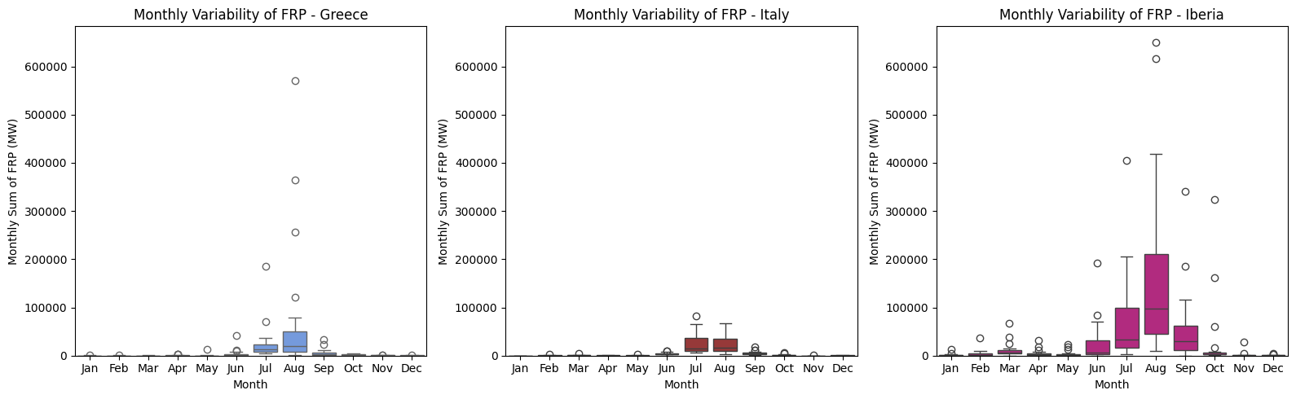

Figure 4 - Monthly variability across all years of FRP values (2003-2024)

Figure 5 compiles the annual total of FRP values for every year in the dataset, this intends to show which region had more intense fire incidents. Iberia is the predominant region with more fires per year, not only because it counts two countries but also includes Portugal that is known for having many occurrences of fires in the summer months.

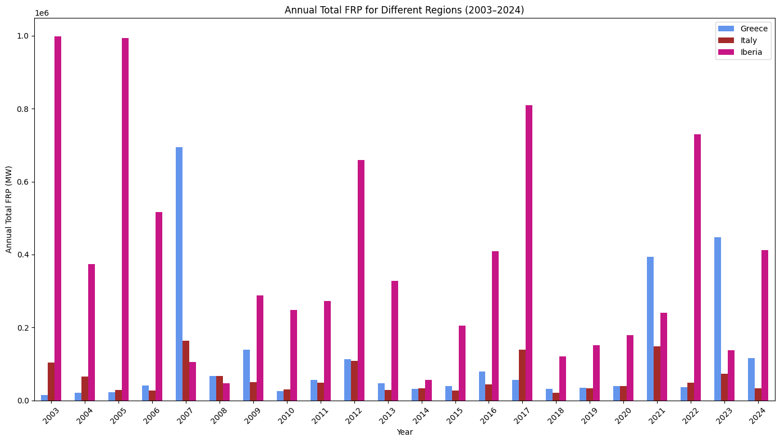

Figure 5 - Total of FRP for each region by year (2003-2024)

Figure 6 shows the total of fire foci, number of hotspots, for each year (2003-2024). This data can be very useful and compare with the actual FRP released, because when can have many fires with lower FRP values (or higher), or lower hotspots but those having high number of energy released.

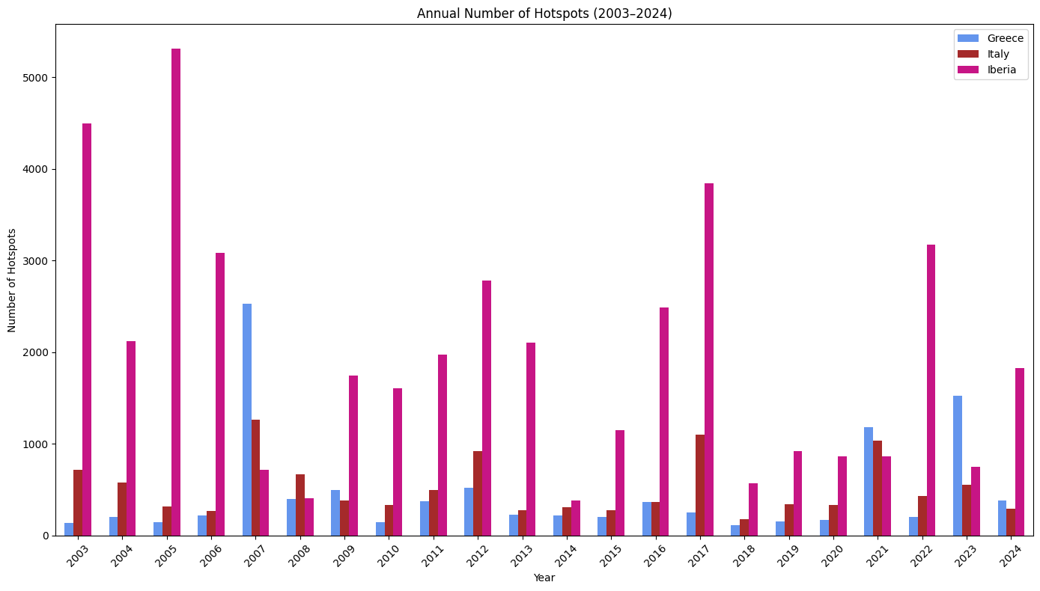

Figure 6 - Total number of hotspots by year, between 2003-2024, for each region

### 3.5.2.Pollutant Data

#### 3.5.2.1.Carbon Monoxide (CO)

Figure X, shows the monthly variability of the daily mean concentration of CO for every region. It is possible to observe large spikes in Greece and Iberia.

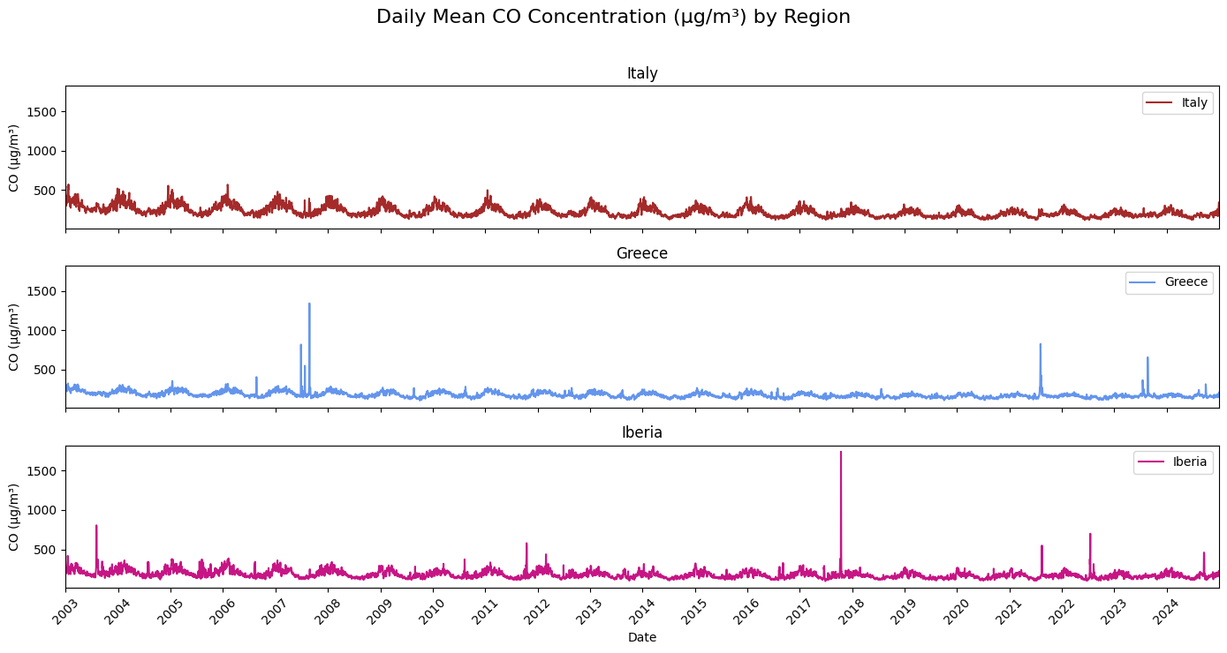

In Figure X, it show the monthly variability of daily mean of CO concentration where it is possible to see the variation across the winter and summer months.

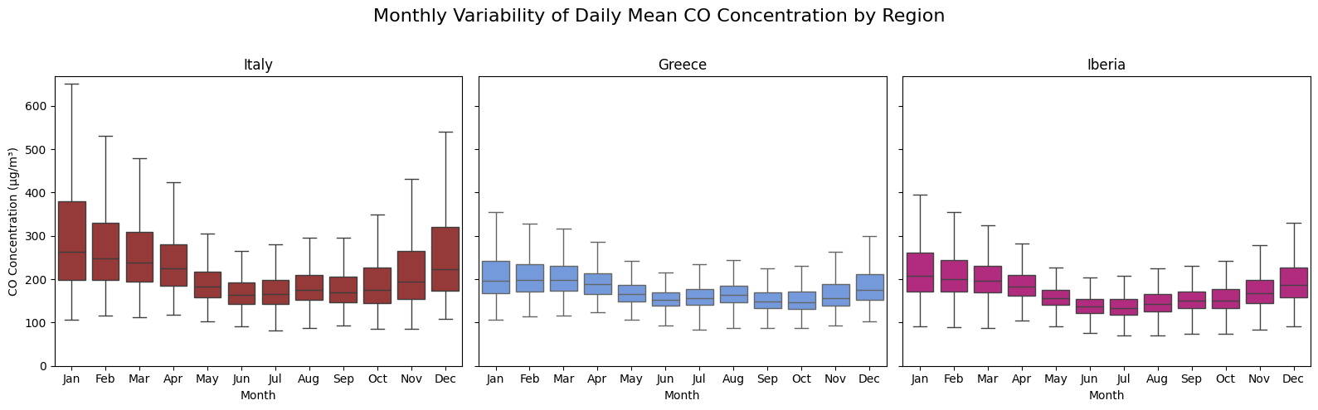

#### 3.5.2.2.Nitrogen Dioxide (NO2)

For NO2, in Figure X, it is clearly of its variation across the winter and summer months.

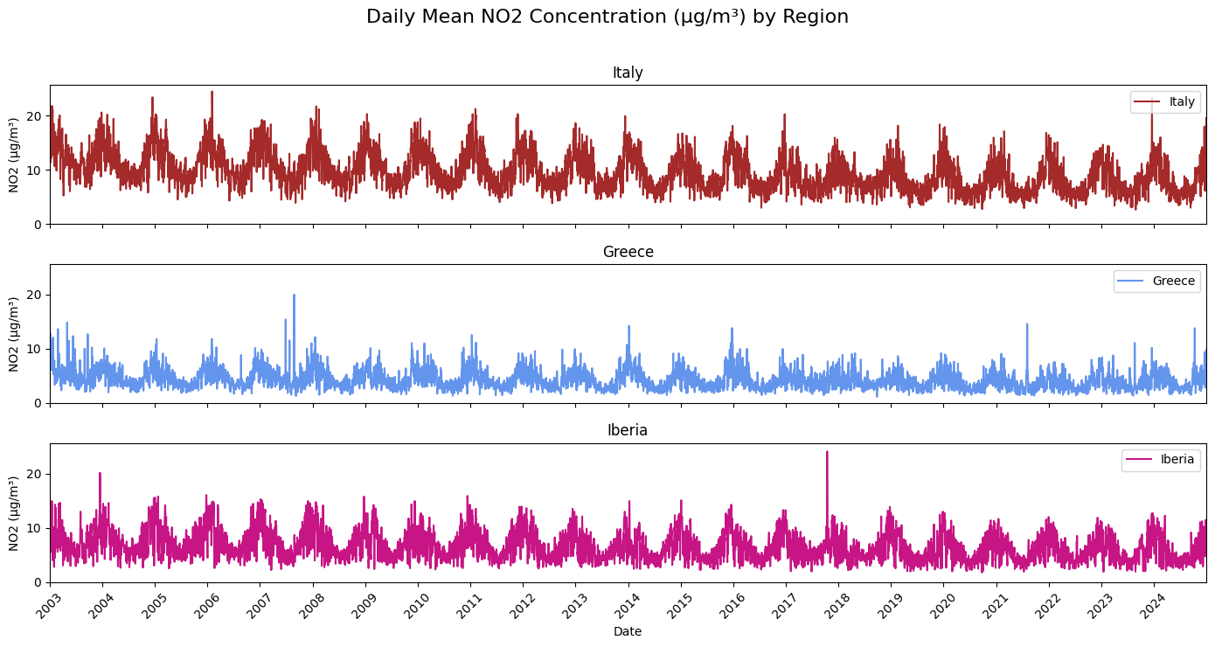

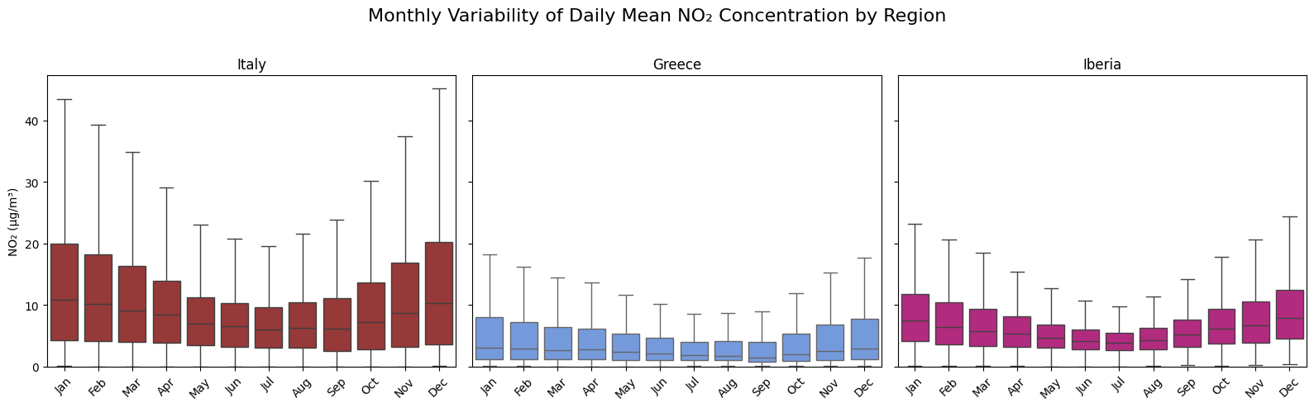

#### 3.5.2.3.Particulate Matter d < 2.5 μm (PM2.5)

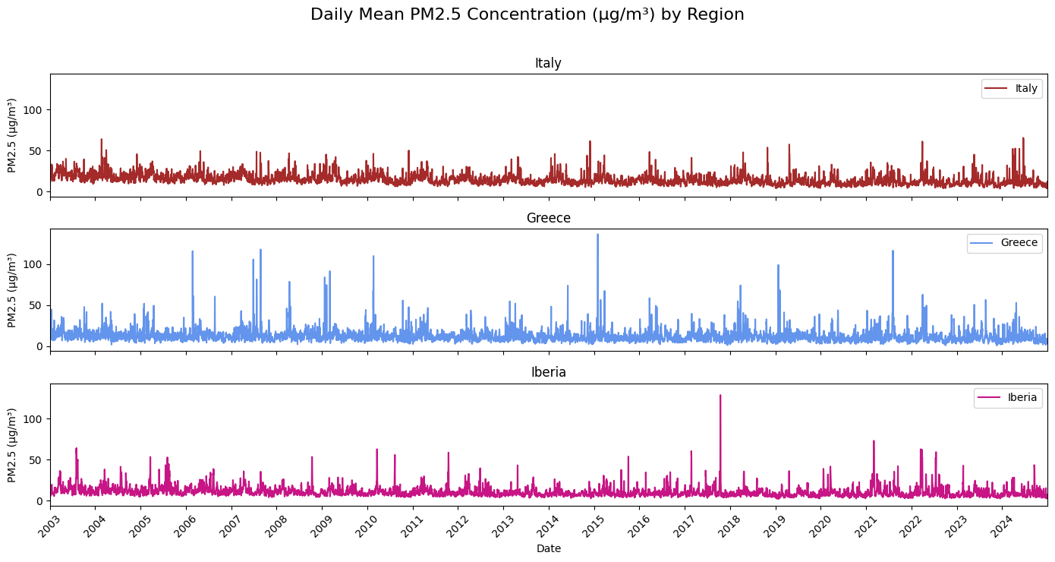

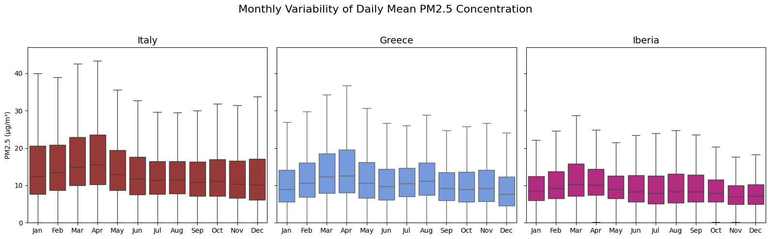

### 3.5.3.Meteorological Data

# 4.Methodology

Based on the work developed by (Moura, et al., 2024) they divided their entire period into fire labels. It consists of assessing what days had fire or no fire recorded, then for the days that occurred a fire, that day counted has the day of the outbreak or Day 0, and up to five days after the start of the episode. In the current work the same was developed, given the extensity of the dataset after Day 5, if the fire persisted after said day, the script would backtrack to Day 0.

Figure X, shows, for Iberia, that the daily mean concentration of every pollutant present is lower for days without fire than the days with fire. And on days with fire the pollutants concentration grows exponentially, meaning that after the fire breaks all pollutants in the study tend to grow its concentration in the air.

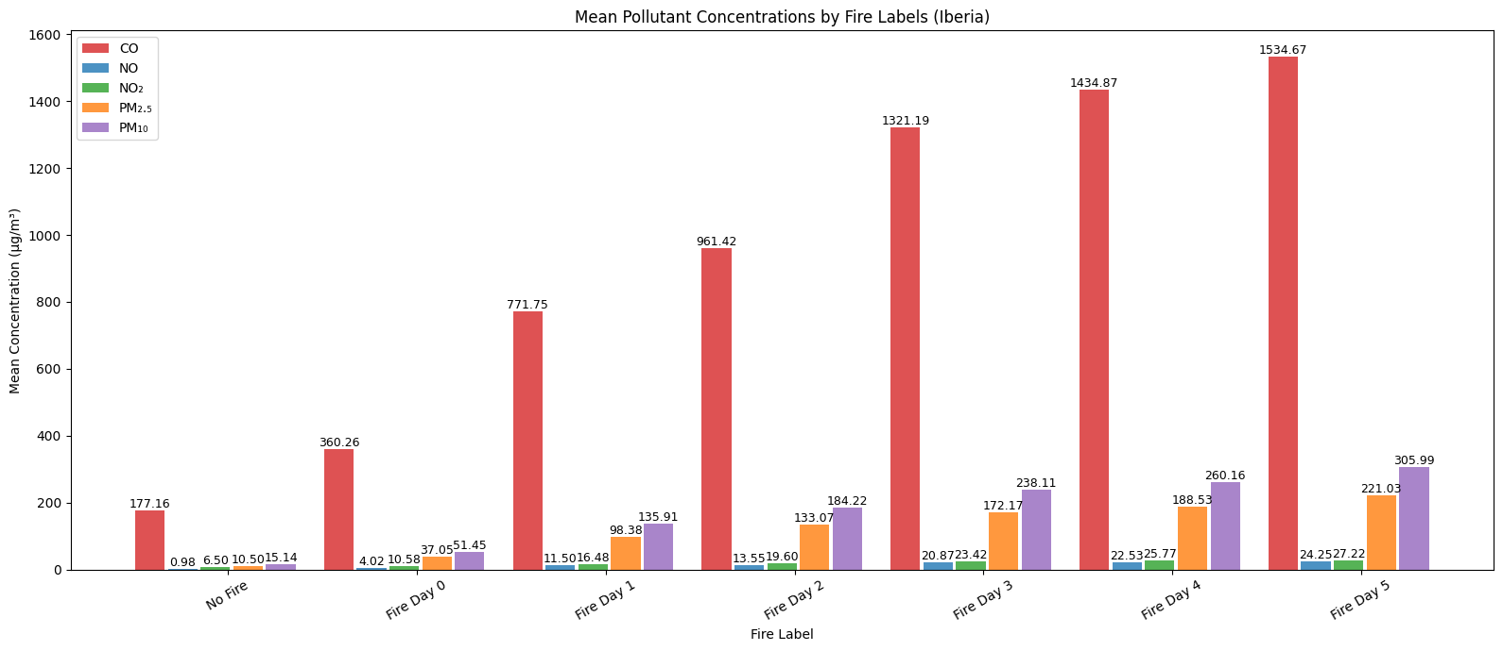

For Greece, in Figure X, the pollutants concentrations are still lower when there is no fire active. In this case, it is still possible to see the growth after the fire outbreak, but there is a decrease in the concentration around the Day 3 and Day 4. Day 5 shows again an increase that could indicate that Greece only tends to have fires active for the first 3 days or so. Because od the way the script to obtain these labels is constructed it is possible to that Day 5 is counting new fire outbreaks and that’s why there is an increase in the concentration.

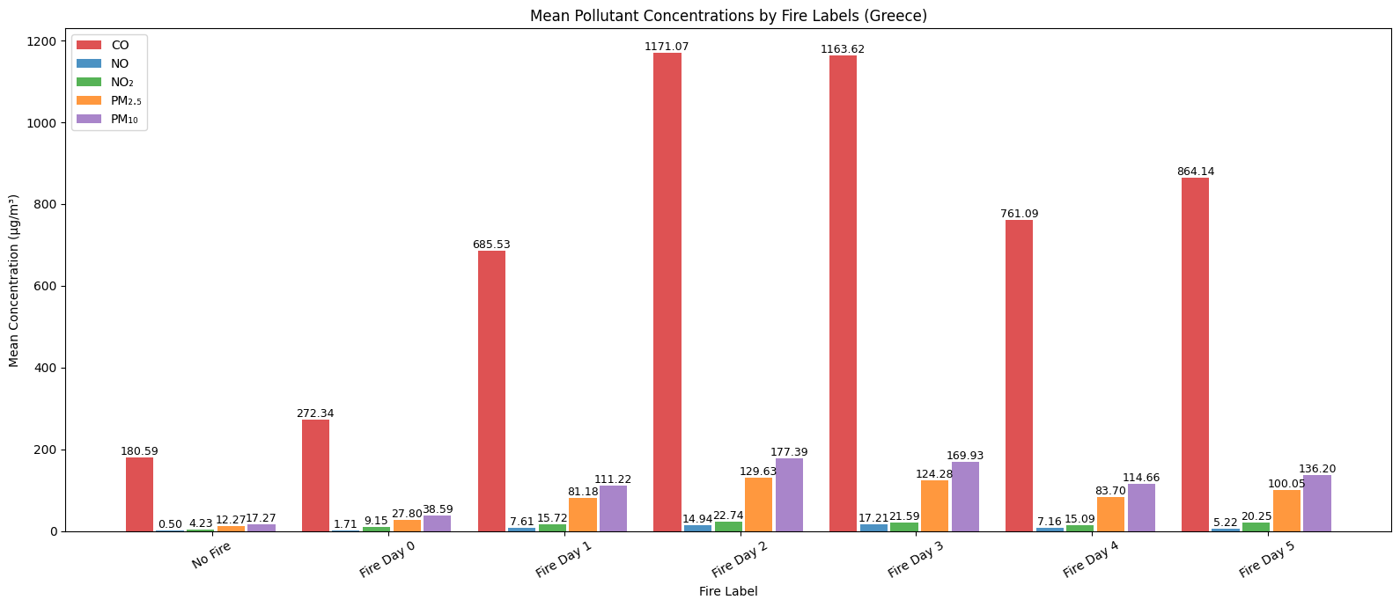

In the case of Italy, in Figure X, there are high values of concentration when there is no fire compared to the days of the fire outbreak. This could mean that might have other sources providing these levels of pollution on days without fire. On days that there is a presence of fire the same case applies for Italy as already described for Greece. There is an increase of the concentrations from the Day 0 up to Day 3 and Day 4, and then the values start decreasing in Day 5.

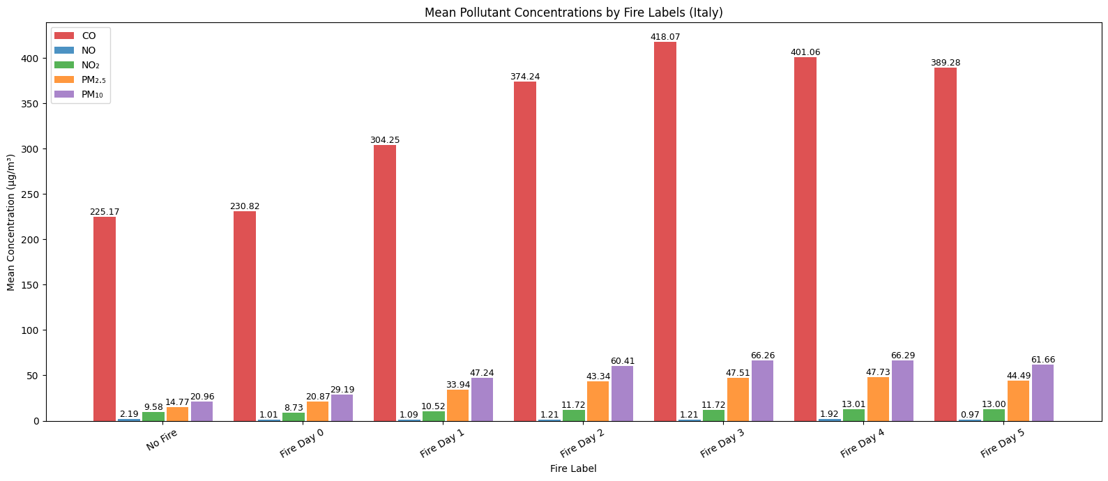

Iberia

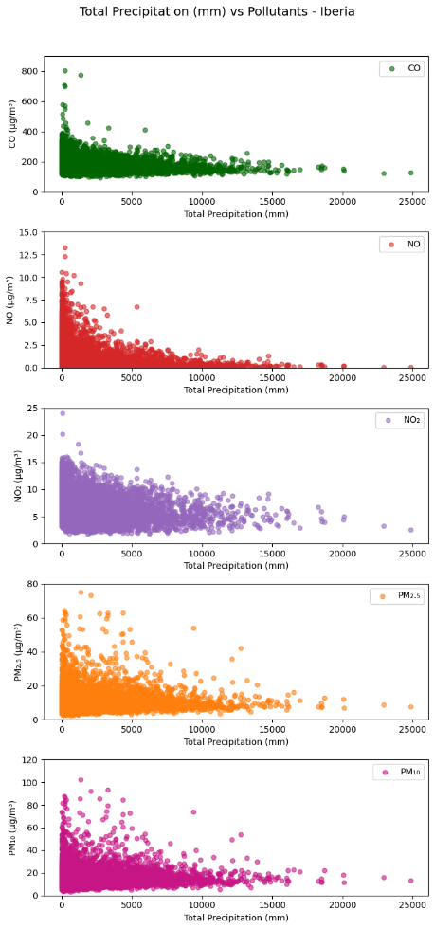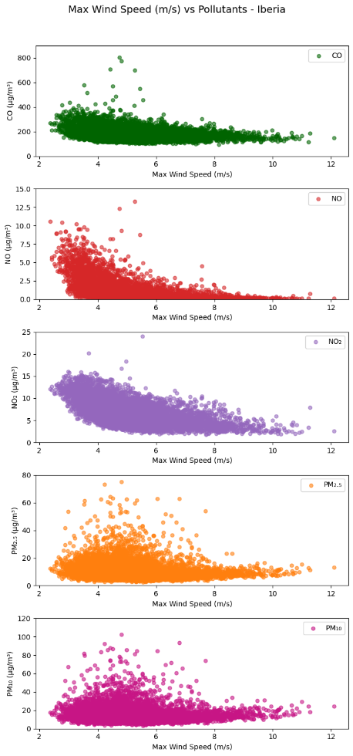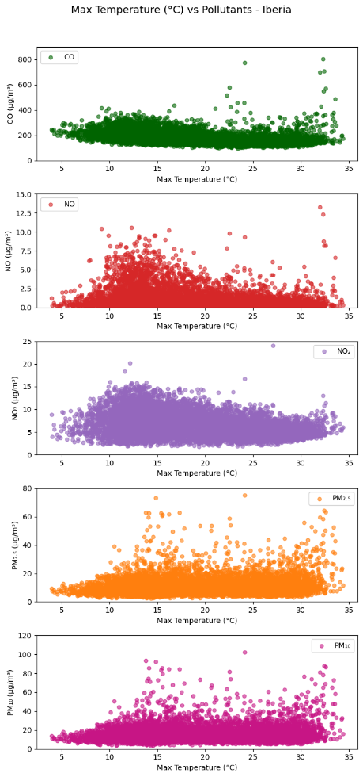

Greece

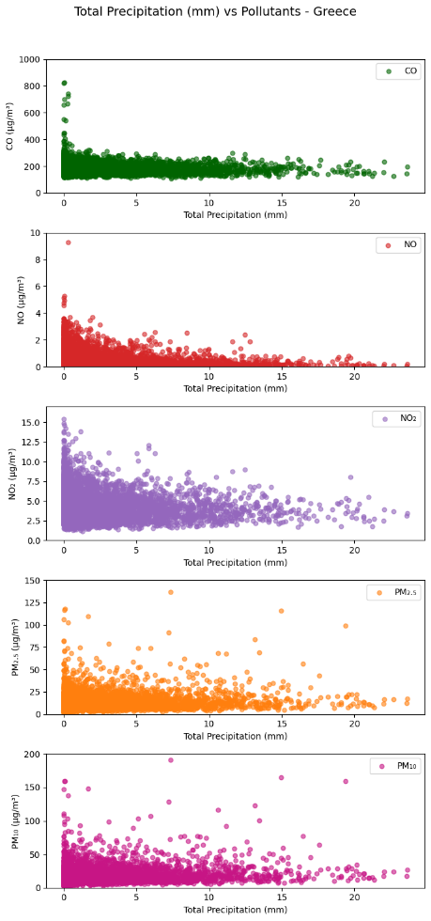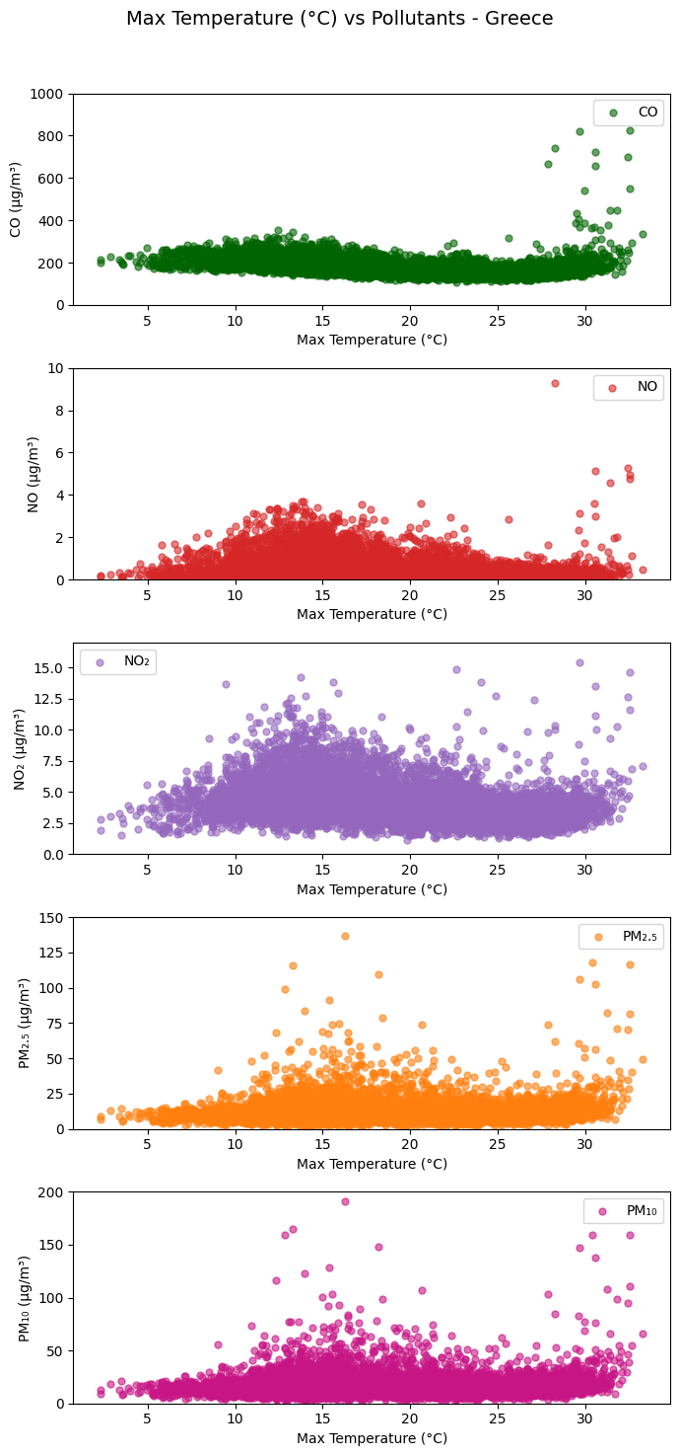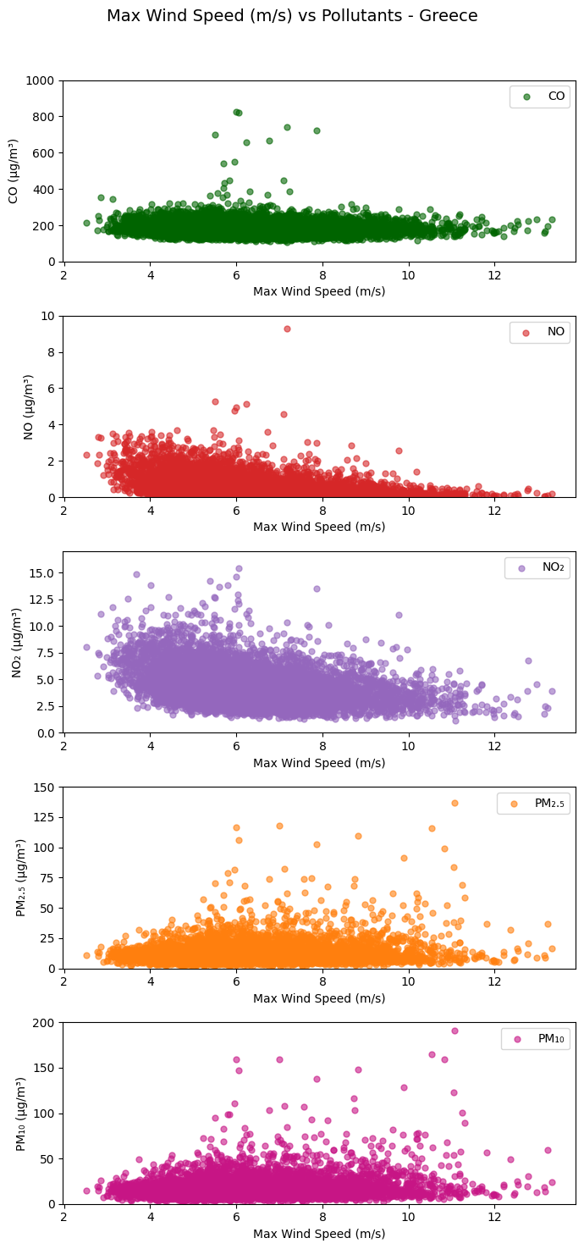

Italy

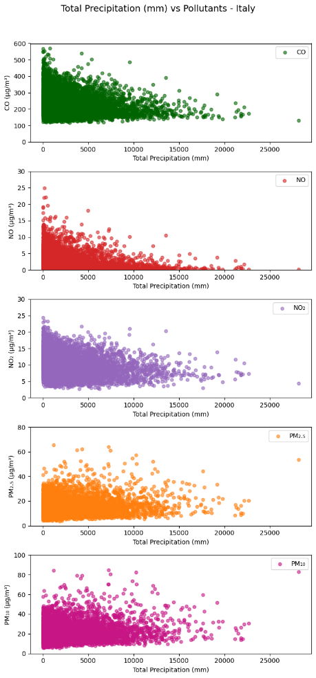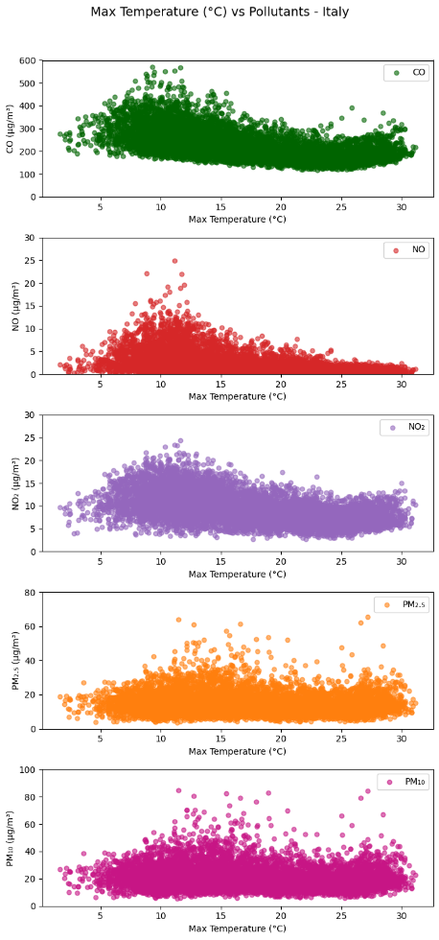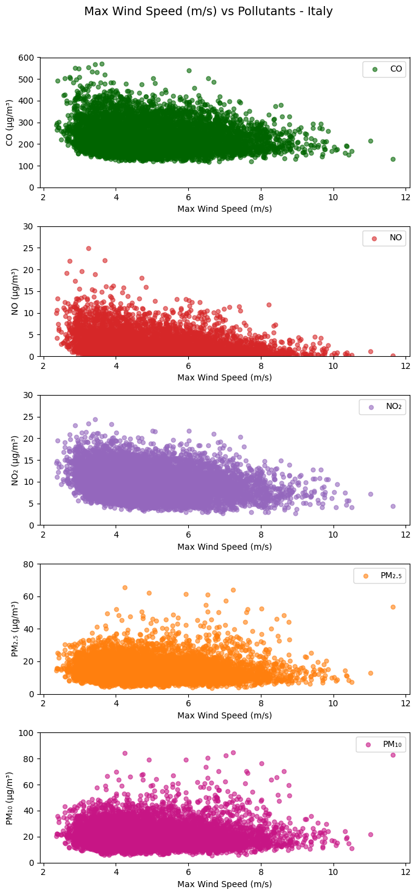

Global Mean

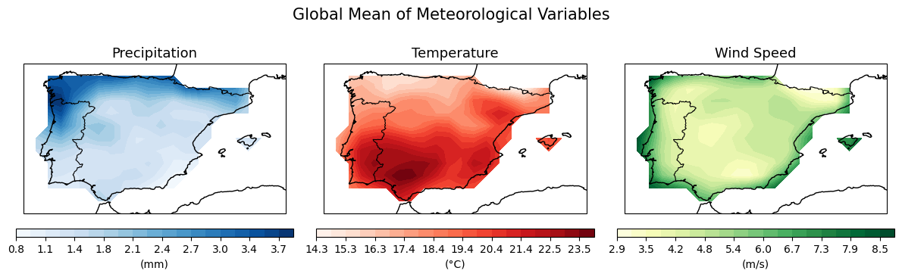

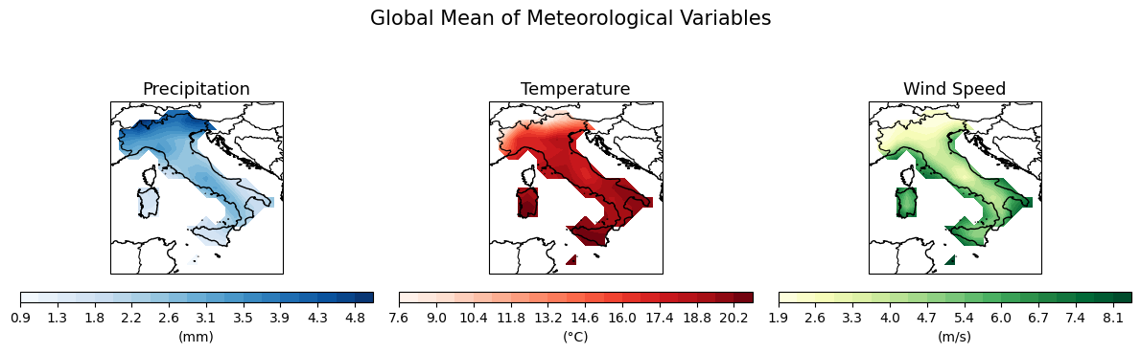

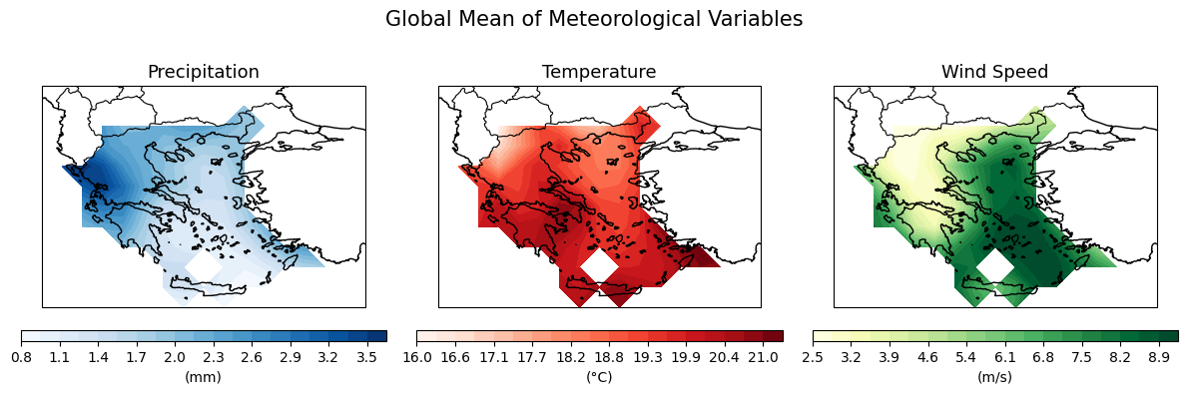

Iberia – High and Low Composites

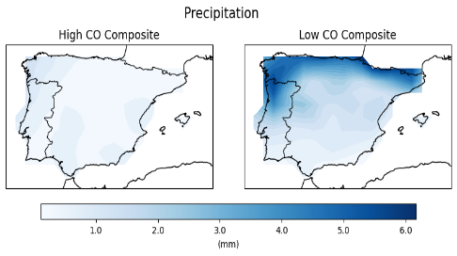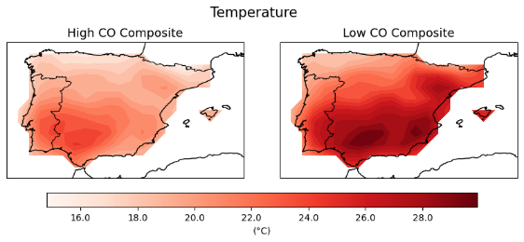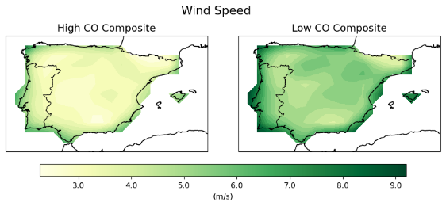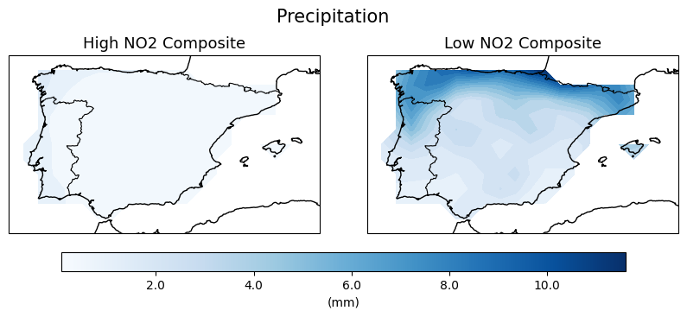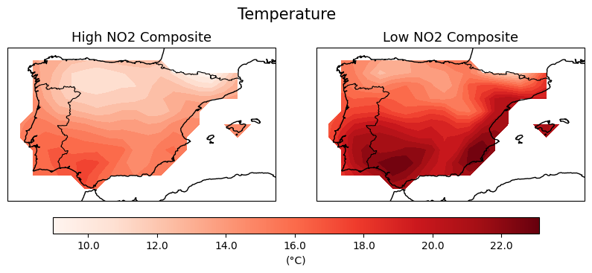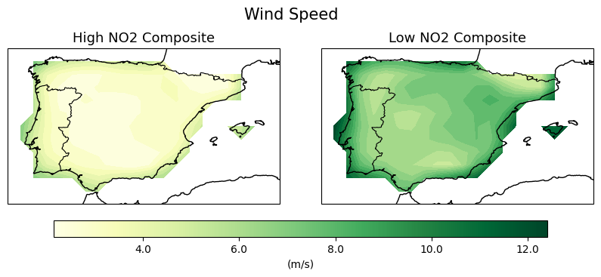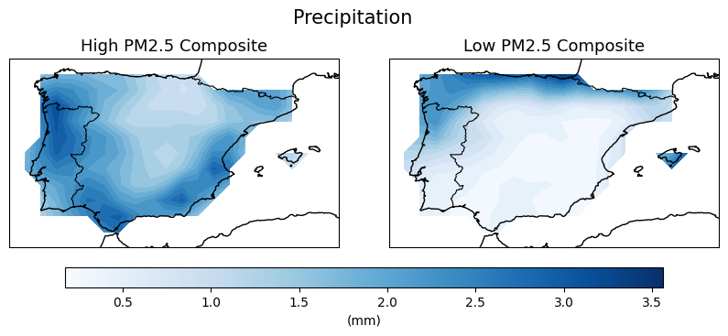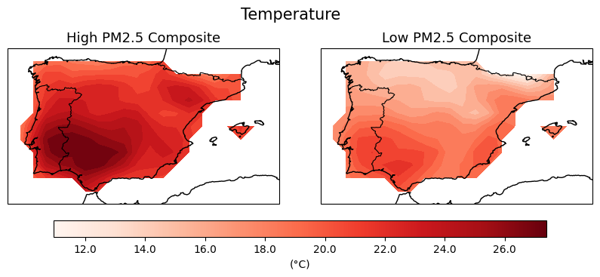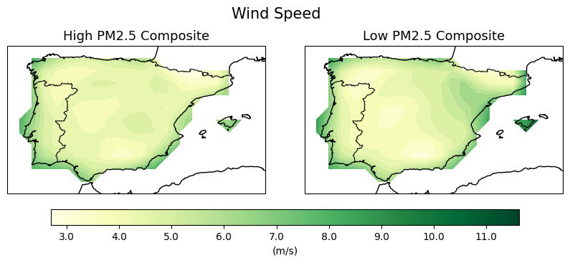

Iberia – High and Low Anomalies

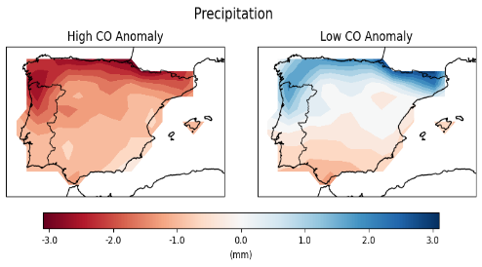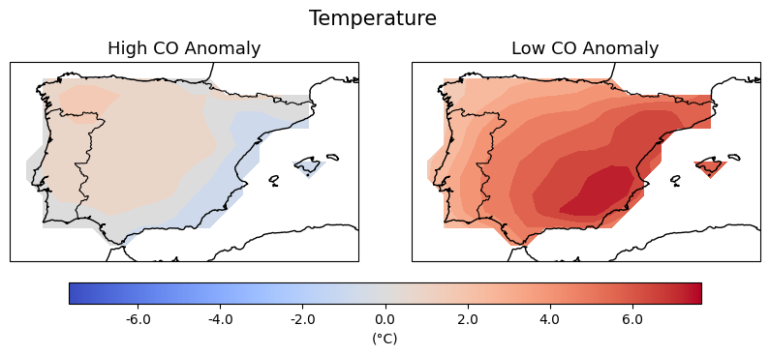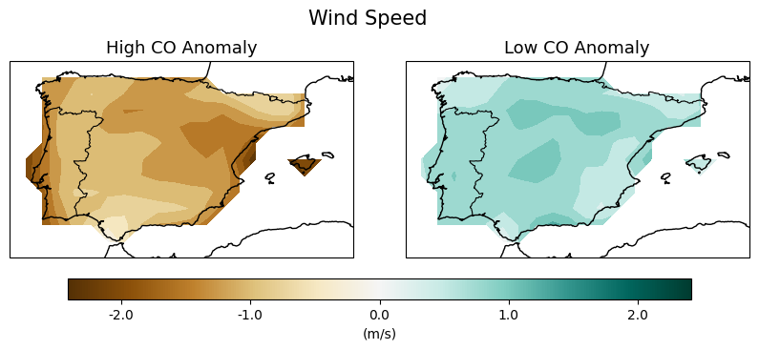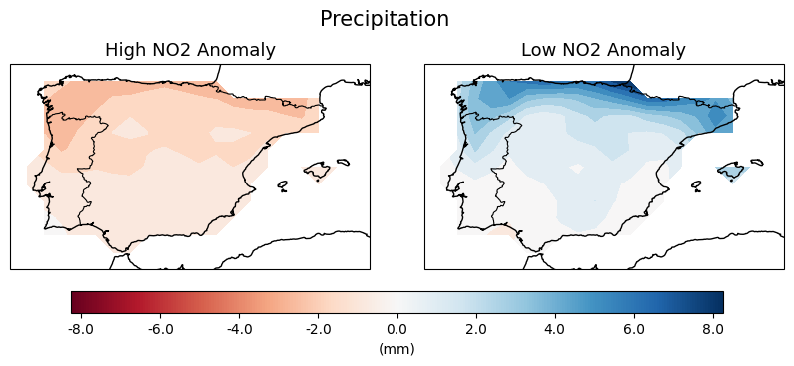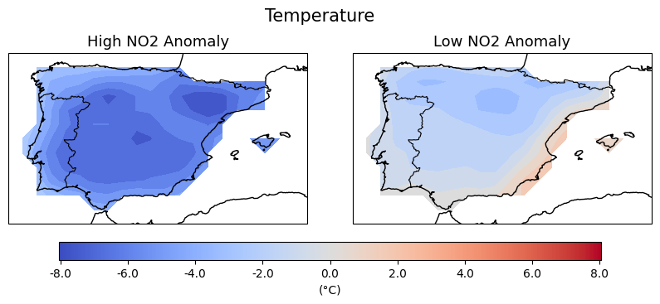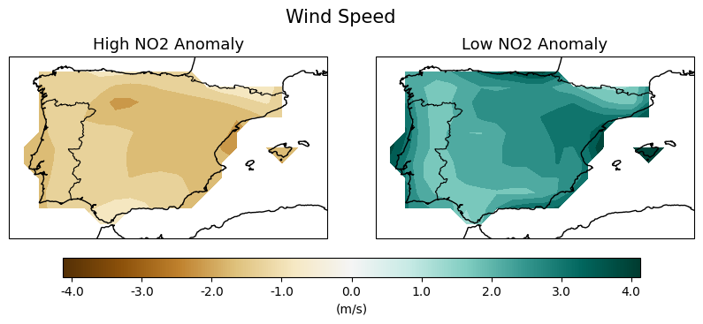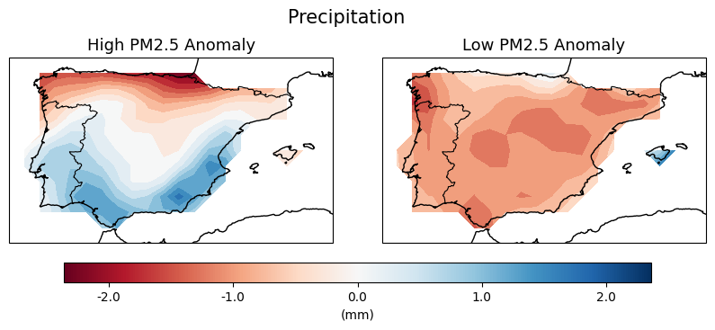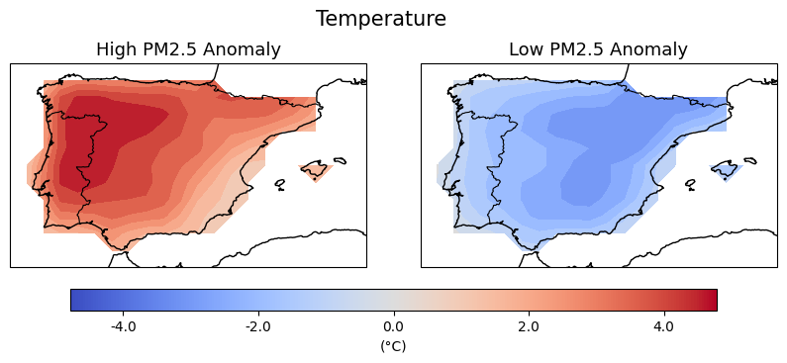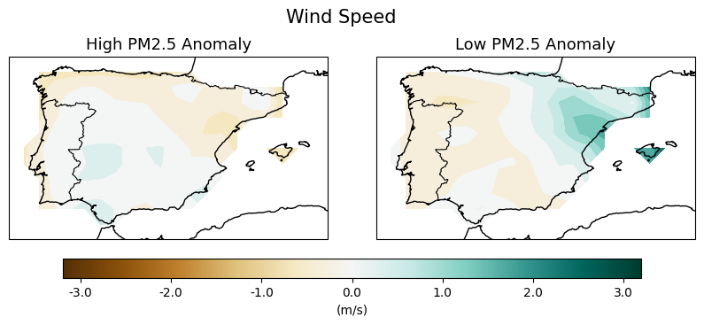

Italy – High and Low Composites

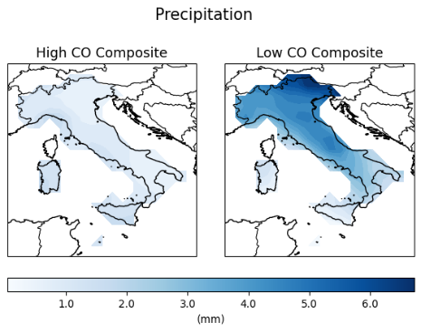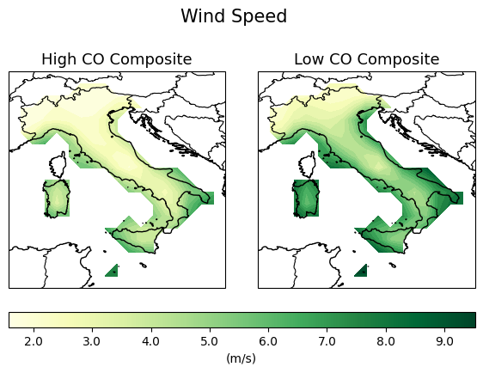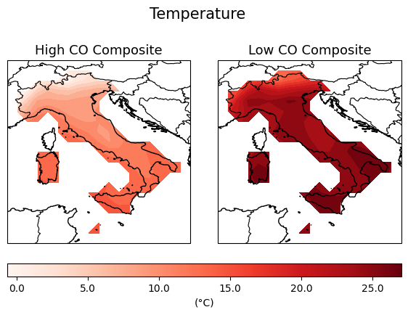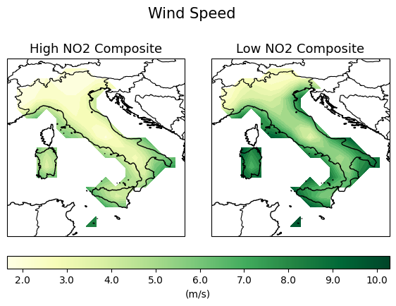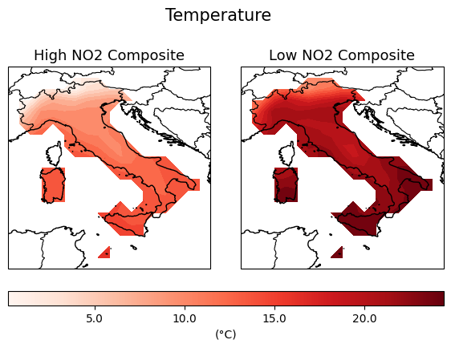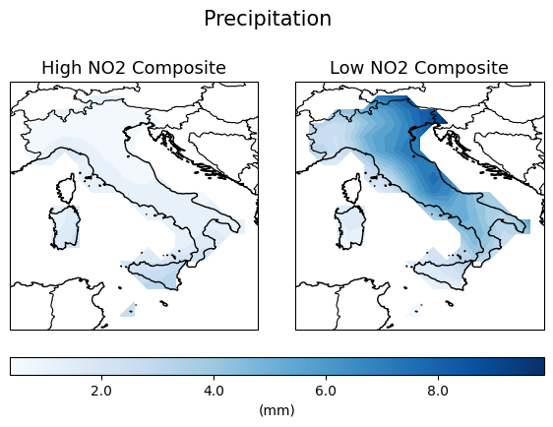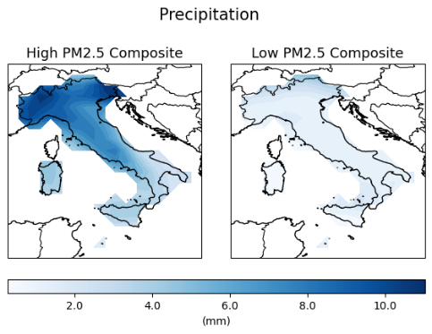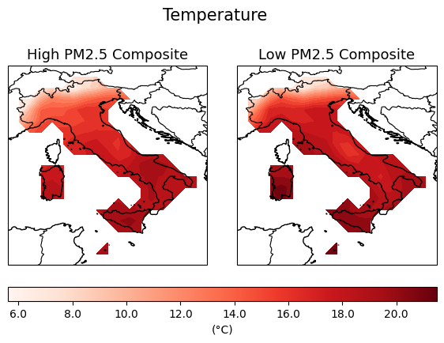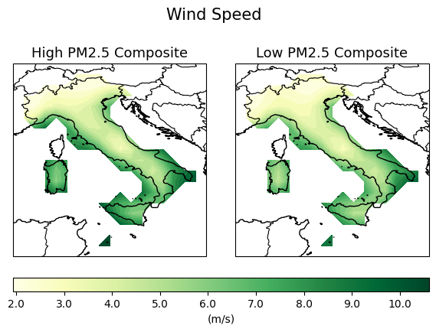

Italy – High and Low Anomalies

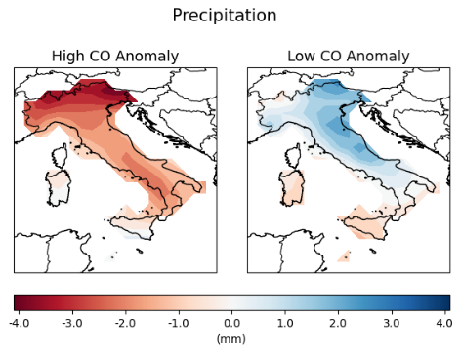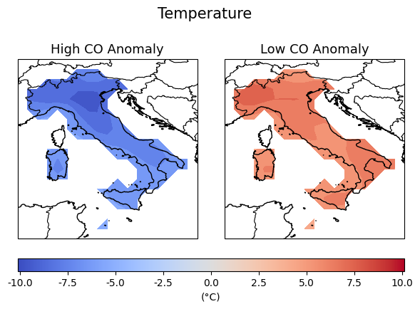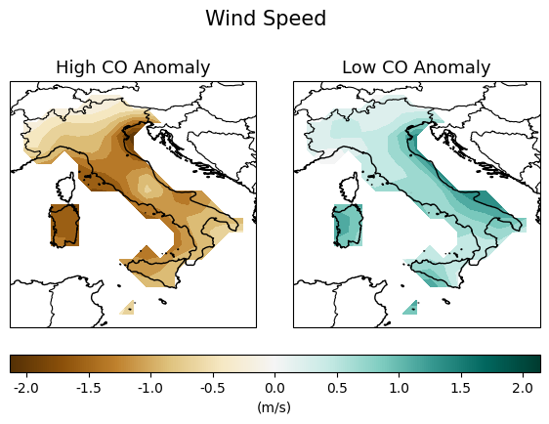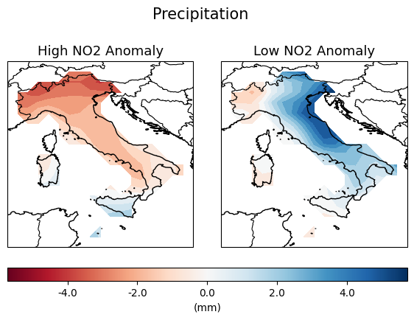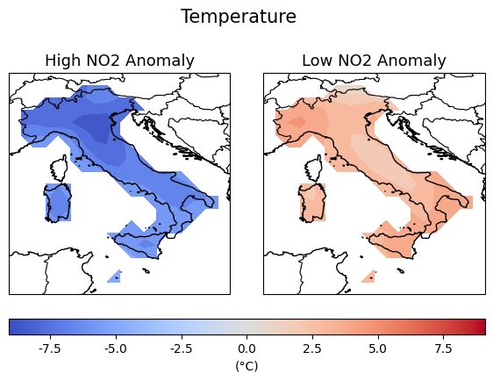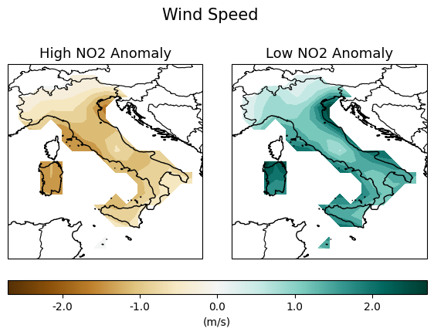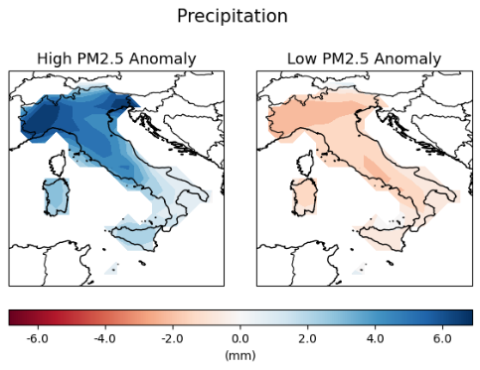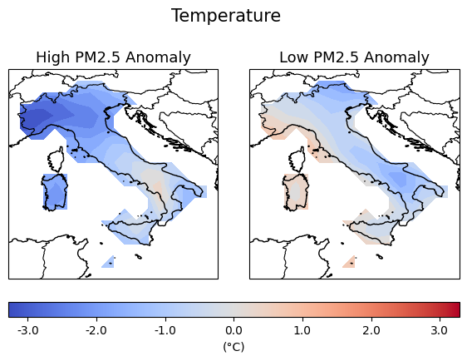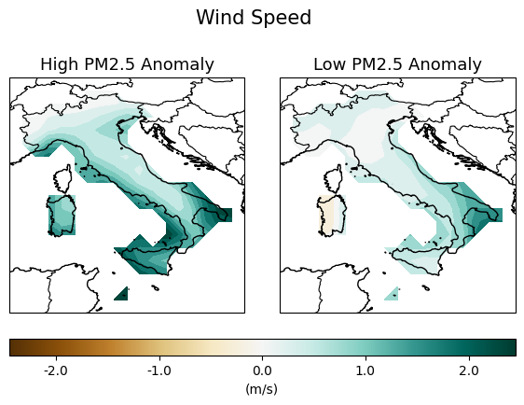

Greece – High and Low Composites

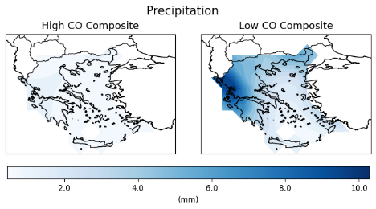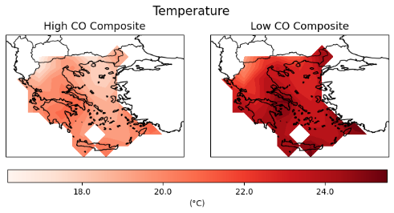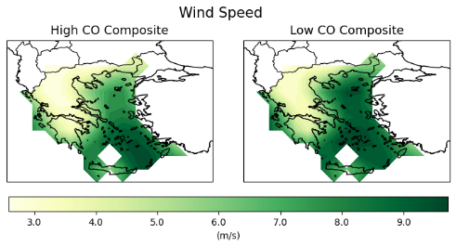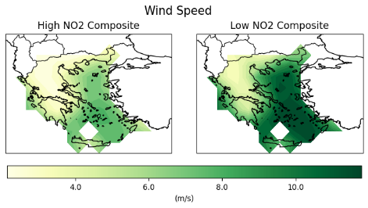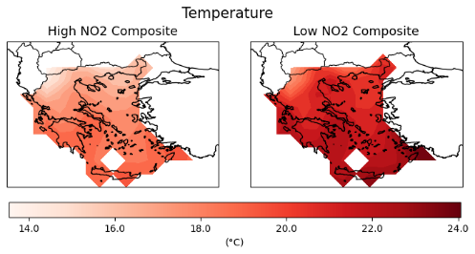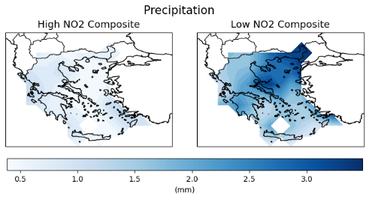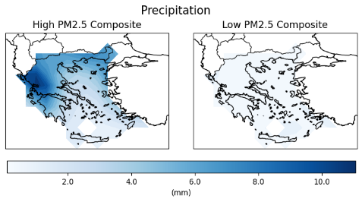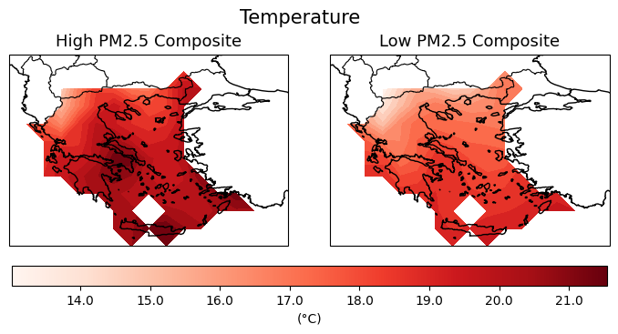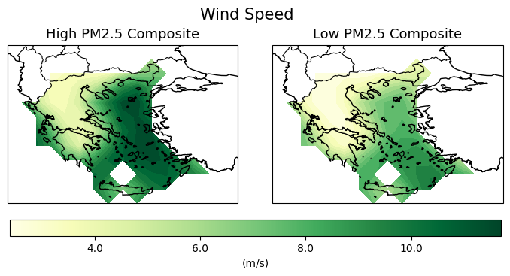

Greece – High and Low Anomalies

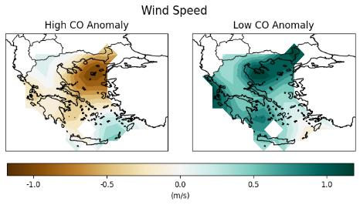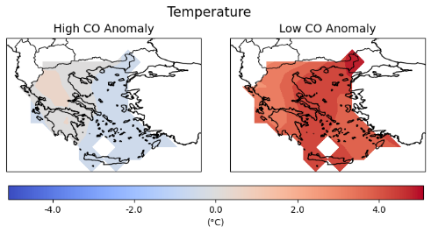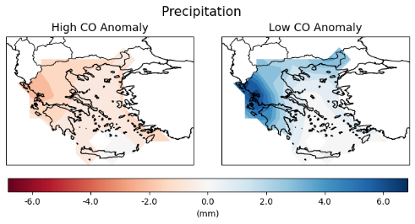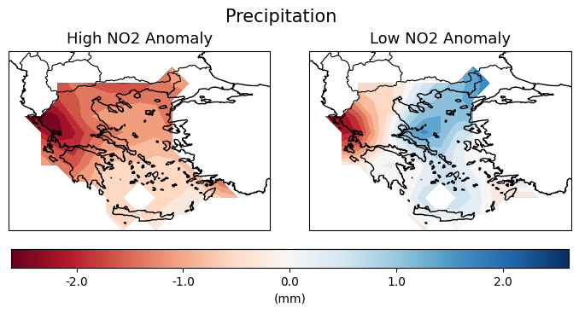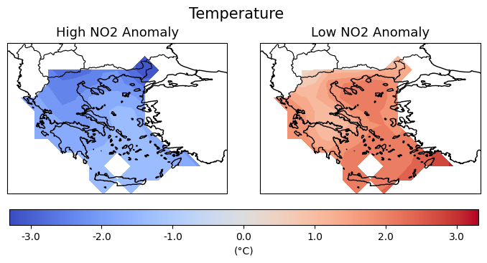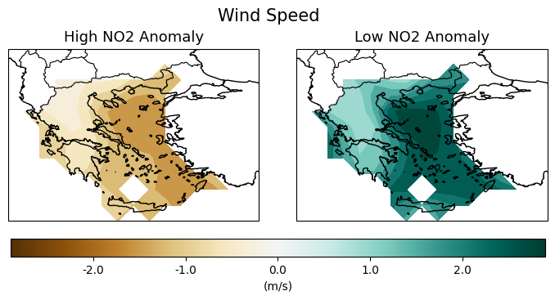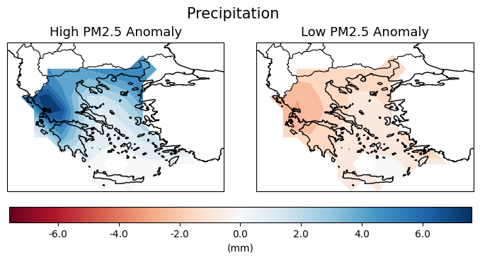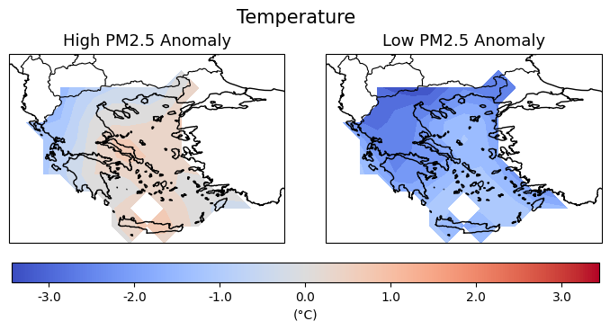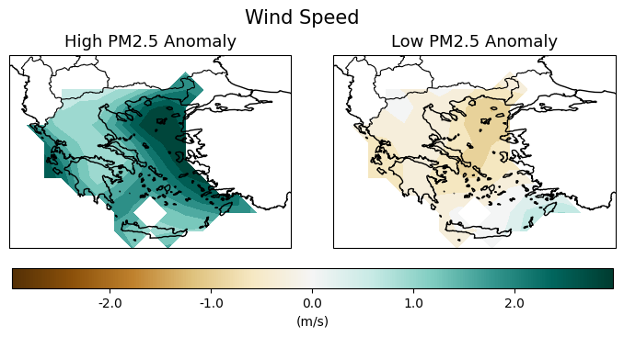

Machine learning (ML) is a subset of artificial intelligence (AI) that allows systems to learn from data and improve their performance over time without explicit programming, playing a crucial role in extracting insights, detecting patterns, and automating processes across different topics. While all ML is considered AI, not all AI encompasses machine learning. As data generation grows exponentially, ML helps businesses analyse vast and large datasets to uncover trends and make predictions. It encompasses different learning types, including supervised, unsupervised, semi-supervised, and reinforcement learning – each suited for different tasks. **Supervised learning** relies on labelled data to train models, such as predicting wildfire occurrences based on historical data and meteorological variables, while **unsupervised learning** identifies patterns and clusters in unlabelled data, like grouping areas with similar wildfire risk levels. **Semi-supervised learning** combines both approaches to reduce labelling costs, iteratively improving models with pseudo-labelling. **Reinforcement learning**, on the other hand, involves trial-and-error learning with feedback, commonly used in optimizing fire suppression strategies or assessing the effectiveness of air quality control measures during wildfire events. ML uses algorithms like **neural networks**, which mimic the human brain to analyse complex data like images; **linear regression**, that predicts continuous outcomes by fitting a line to data points but may struggle with non-linear relationships; **logic regression**, used for binary outcomes like wildfire-induced health impacts; **clustering**, an unsupervised method that groups similar data points into clusters for tasks like mapping areas with similar air pollution profiles due to wildfires; **decision trees**, which make predictions using simple if-then rules; and **random forests**, an ensemble of decision trees that improve prediction accuracy by addressing limitation like overfitting. By training algorithms on data, ML models identify complex relationships, enabling automatic pattern discovery, predictive analysis and large-scale data processing. This makes it crucial to select the right learning approach based on data structure, resources, and application needs ​(Chen, 2024)​.

Machine learning models are built by training statistical algorithms on data rather than relying on predefined rules. The development process follows key steps: (1) **Data collection** – gathering and evaluating high-quality data, which may require extensive preprocessing and labelling; (2) **Algorithm selection** – choosing the appropriate approach (supervised, unsupervised, semi-supervised, or reinforcement learning) based on the problem; (3) **Data preparation** – cleaning, transforming, and structing data for efficient processing; (4) **Model training** – feeding the data into the algorithm, adjusting hyperparameters, and iterating to improve performance; (5) **Performance assessment** – evaluating accuracy using test data and refining the model accordingly; (6) **Fine-tuning** – further optimizing parameters and incorporating domain-specific data; (7) **Deployment and monitoring** – integrating the model into real-world application, tracking its performance, and making periodic updates to maintain accuracy and relevance. Continuous evaluation ensures that models remain effective and aligned with business or research objectives ​(Chen, 2024)​.

Atmospheric dispersion models are mathematical models used to simulate how air pollutants (gases and particles) spread in the atmosphere. These models take into account meteorological conditions, chemical reactions, and physical dispersion processes to estimate pollutant concentrations at different locations. There are two main types of dispersion models: Gaussian models used for local, near-source dispersion (e.g., air pollution from traffic); Eulerian and Lagrangian models that are used for regional or global scales, incorporating meteorological and chemistry ​(Holmes & Morawska, 2006)​.

Model Development:

* Supervised Machine Learning Models: Implement and compare models (e.g., Random Forests, XGBoost, and Neural Networks) to classify pollution events and identify anomalies related to wildfire smoke.
* Spatial and Temporal Analysis: Use geospatial tools to map the spatial reach of pollution plumes, identifying the temporal dynamics of smoke dispersal patterns.

Evaluation and Validation:

* Validate the model using metrics such as accuracy, F1-score, and area under the curve (AUC) for classification tasks.
* Cross-reference predicted pollution events with historical extreme events (e.g., Portugal’s 2017 megafires) to validate spatial and temporal accuracy. Analyse the impact of compound events (e.g. droughts and heatwaves) to the magnitude of fire-driven pollution events.

# 5.Results

Model Performance:

* Present the results of model performance, discussing the predictive accuracy in detecting pollution events and identifying contributing factors from FRE, FRP, and meteorological data.

# 6.Discussion

Spatial and Temporal Impact Analysis:

* Discuss the spatial and temporal patterns of wildfire smoke distribution. Evaluate how FRP and FRE data correlate with pollutant concentrations across affected regions.

Limitations and Future Improvements:

* Discuss potential limitations of the model, such as sensitivity to specific atmospheric conditions or data quality, and suggest directions for future improvement.

# 7.Conclusion

Summary of Findings:

* Summarize the effectiveness of remote sensing and meteorological data in detecting and mapping wildfire-induced pollution events.

Implications:

* Discuss the potential of this approach to support decision-making interventions and policy planning.

Future Work:

* Suggest advancements in real-time monitoring systems, the inclusion of additional data sources, and potential integration with other environmental and health monitoring frameworks.

# References

AghaKouchak, A., Chiang, F., Huning, L. S., Love, C. A., Mallakpour, I., Mazdiyasni, O., . . . Sadegh, M. (2020). *Climate Extremes and Compound Hazards in a Warming World.* Annual Reviews. doi:https://doi.org/10.1146/annurev-earth-071719-055228

Bento, V. A., Lima, D. C., Santos, L. C., Lima, M. M., Russo, A., Nunes, S. A., . . . Soares, P. M. (2023). The Future of extreme meteorological fire danger under climate change scenarios for Iberia. *Elsevier, 42*. doi:https://doi.org/10.1016/j.wace.2023.100623

Ceamanos, X., Coopman, Q., George, M., Riedi, J., Clerbaux, C., & Parrington, M. (2023). Remote sensing and model analysis of biomass burning smoke transported across the Atlantic during the 2020 Western US wildfire season. doi:https://doi.org/10.1038/s41598-023-39312-1

Chen, M. (25 de November de 2024). *What is Machine Learning?* Obtido em 26 de February de 2025, de oracle.com: https://www.oracle.com/uk/artificial-intelligence/machine-learning/what-is-machine-learning/

Copernicus. (2025). *About Copernicus*. Obtido em 25 de February de 2025, de copernicus.eu: https://www.copernicus.eu/en/about-copernicus

Copernicus. (2025). *CAMS global reanalysis (EAC4) - Overview*. Obtido em 26 de February de 2025, de ads.atmosphere.copernicus.eu: https://ads.atmosphere.copernicus.eu/datasets/cams-global-reanalysis-eac4?tab=overview

Copernicus. (2025). *EFFIS Annual Statistics for Greece*. Obtido em 4 de december de 2025, de forest-fire.emergency.copernicus.eu: https://forest-fire.emergency.copernicus.eu/apps/effis.statistics/estimates/GRC

Copernicus. (2025). *EFFIS Annual Statistics for Italy*. Obtido em 4 de december de 2025, de forest-fire.emergency.copernicus.eu: https://forest-fire.emergency.copernicus.eu/apps/effis.statistics/estimates/ITA

Copernicus. (2025). *EFFIS Annual Statistics for Portugal*. Obtido em 3 de january de 2026, de forest-fire.emergency.copernicus.eu: https://forest-fire.emergency.copernicus.eu/apps/effis.statistics/estimates/PRT

Copernicus. (2025). *EFFIS Annual Statistics for Spain*. Obtido em 3 de january de 2026, de forest-fire.emergency.copernicus.eu: https://forest-fire.emergency.copernicus.eu/apps/effis.statistics/estimates/ESP

Copernicus. (2025). *ERA5 hourly data on single levels from 1940 to present - Overview*. Obtido em 25 de February de 2025, de cds.climate.copernicus.eu: https://cds.climate.copernicus.eu/datasets/reanalysis-era5-single-levels?tab=overview

De Sario, M., Katsouyanni, K., & Michelozzi, P. (2013). *Climate change, extreme weather events, air pollution and respiratory health in Europe.*

Durao, R., Alonso, C., Russo, A., & Gouveia, C. (14-19 de April de 2024). *The role of fire radiative power to estimate fire-related smoke pollution.* Vienna, Austria: EGU General Assembly 2024. doi:https://doi.org/10.5194/egusphere-egu24-13237

Expatica. (2025). *Portugal: a history of deadly forest fires*. Obtido em 9 de September de 2025, de Expatica for internationals: https://www.expatica.com/pt/news/portugal-fire-precedents-55389/

Fascinating Spain. (8 de october de 2024). *The Worst Fires in the History of Spain*. Obtido em 9 de september de 2025, de Fascinating Spain: https://www.fascinatingspain.com/articulo/history-and-legends/worst-fires-history-of-spain/20220911141900068663.html

Holmes, N. S., & Morawska, L. (2006). A review of dispersion modelling and its application to the dispersion of particles: An overview of different dispersion models available. *Elsevier*, 5902-5928. doi:https://doi.org/10.1016/j.atmosenv.2006.06.003

IBM. (2025). *What is an API (application programming interface)?* Obtido em 18 de december de 2025, de ibm.com: https://www.ibm.com/think/topics/api

Instituto de Meteorologia. (23 de March de 2009). *Fire Radiative Power Pixel - MSG*. Obtido em 24 de February de 2025, de geonetcastamericas.noaa.gov: https://www.geonetcastamericas.noaa.gov/products/navigator/details/EO_EUM_DAT_MSG_FRP-SEVIRI.html

Knorr, W., Dentener, F., Lamarque, J.-F., Jiang, L., & Arneth, A. (2017). *Wilfire air pollution hazard during the 21st century.* Atmospheric Chemistry and Physics. doi:https://doi.org/10.5194/acp-17-9223-2017

Li, F., Zhang, X., Kondragunta, S., & Csiszar, I. (2 de May de 2018). Comparison of Fire Radiative Power Estimates From VIIRS and MODIS Observations. *Journal of Geophysical Research: Atmospheres*, 4545-4563. doi:https://doi.org/10.1029/2017JD027823

Moura, F. R., Machado, P. D., Ramires, P. F., Tavella, R. A., Carvalho, H., & Júnior, F. M. (2024). In the line of fire: Analyzing burning impacts on air pollution and air quality in an Amazonian city, Brazil. *Elsevier*. doi:https://doi.org/10.1016/j.apr.2023.102033

NASA. (2025). *Fire Information for Resource Management System*. Obtido em 28 de May de 2025, de https://firms.modaps.eosdis.nasa.gov/

Rizzo, L. V., & Rizzo, M. F. (13 de december de 2024). Wildfire smoke and health impacts: a narrative review. *Jornal de Pediatria*. doi:https://doi.org/10.1016/j.jped.2024.11.006

Ruffault, J., Curt, T., Moron, V., Trigo, R. M., Mouillot, F., Koutsias, K., . . . Belhadj-Khedher, C. (14 de August de 2020). Increased likelihood of heat-induced large wildfires in the Mediterranean Basin. *Nature - Scientific Reports*, 1. doi:https://doi.org/10.1038/s41598-020-70069-z

Schneider, S. R., Lee, K., Santos, G., & Abbatt, J. P. (2021). Ai Quality Data Approach for Defining WIldfire Influence: Impacts on PM2.5, NO2, CO, and O3 i Western Canadian Cities. *Environmental Science & Technology, 55*, 13709-13717. doi:https://doi.org/10.1021/acs.est.1c04042

Statista. (2025). *Area burned by wildfires in Italy from 2009 to 2024*. Obtido em 2025, de Statista: https://www.statista.com/statistics/1264718/area-burned-by-wildfire-in-italy/?srsltid=AfmBOor3V-4K7RvmuA0yhc3yPxTFcYFBMhVFMXDJOzsJNAg4APEK-8g1

WHO. (2025). *What are the WHO Air quality guidelines?* Obtido de https://www.who.int/news-room/feature-stories/detail/what-are-the-who-air-quality-guidelines

World Health Organization. (2025). *Air pollution*. Obtido em 25 de February de 2025, de who.int: https://www.who.int/health-topics/air-pollution#tab=tab_1

World Health Organization. (2025). *Wildfires*. Obtido em 24 de February de 2025, de who.int: https://www.who.int/health-topics/wildfires#tab=tab_1

World Meteorological Organization. (2025). *Extreme Weather*. Obtido em 24 de February de 2025, de wmo.int: https://wmo.int/topics/extreme-weather

Yao, J., & Henderson, S. B. (2013). An empirical model to estimate daily forest fire smoke exposure over a large geographic area using air quality, meteorological, and remote sensing data. *Journal of Exposure Science and Environmental Epidemiology (2014), 24*, 328-335. doi:doi:10.1038/jes.2013.87

# Appendices

Appendix 1 – Representation of FRP intensity for study area, in particular the concentration of fires in the north of Iberia, to explain reason of masks creation. All FRP values below 50 MW were removed to better capture more intense fires

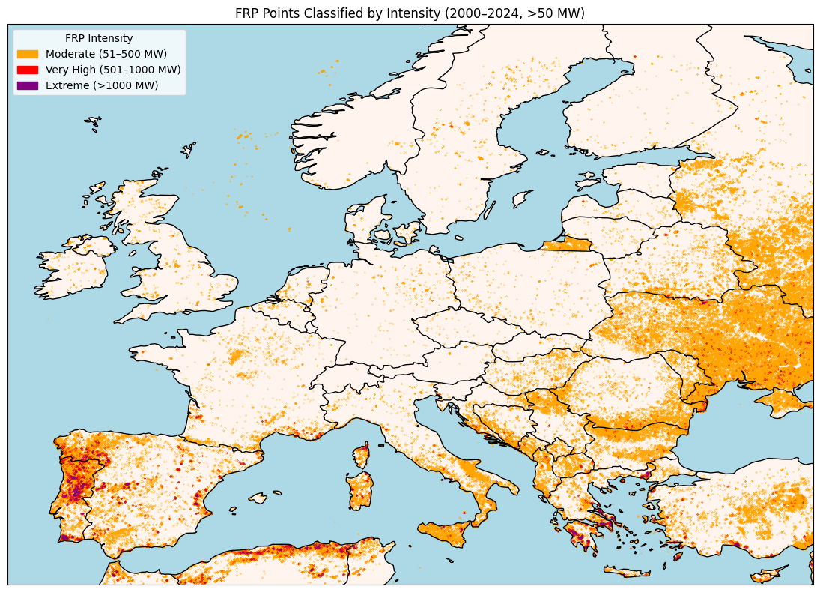

Appendix X -

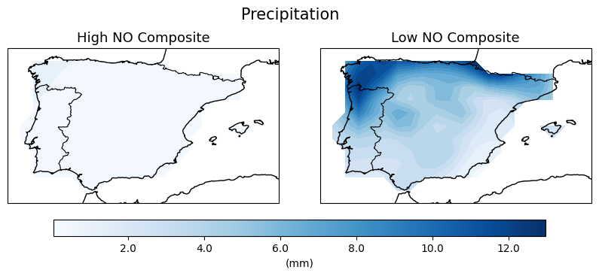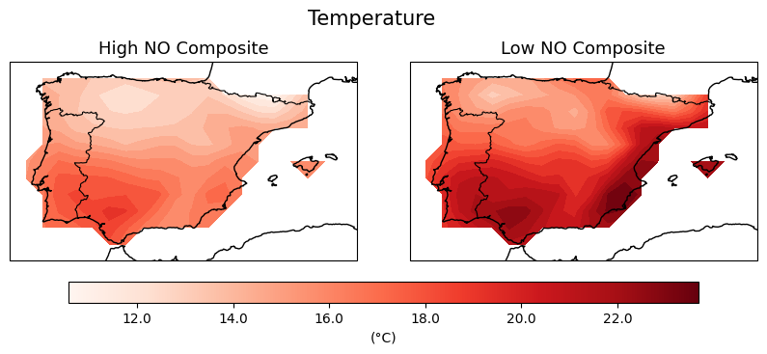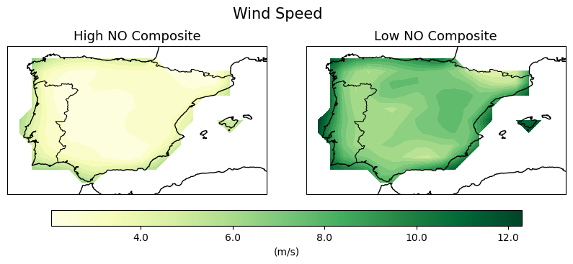

Appendix X -

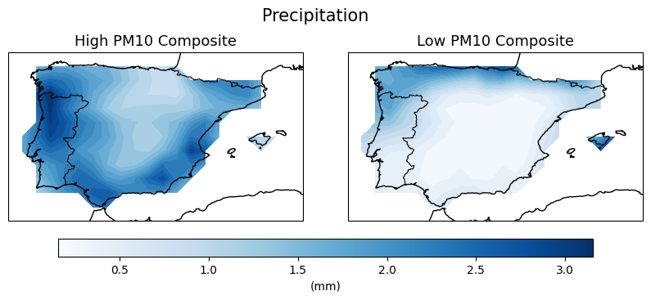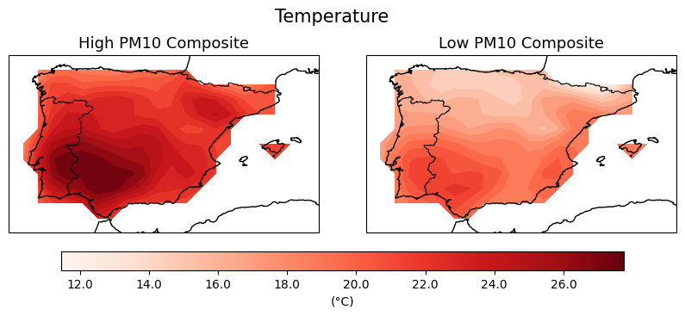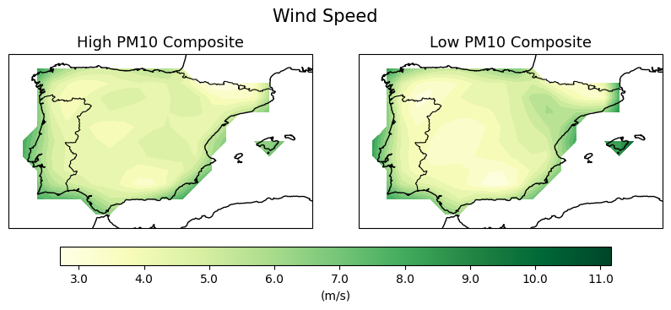

Appendix X –

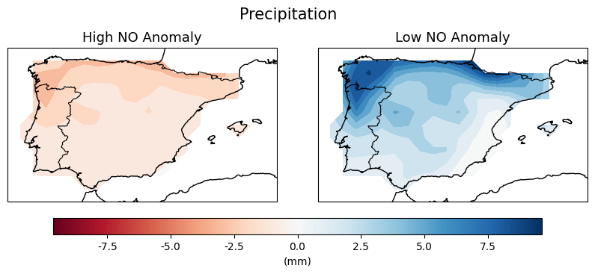 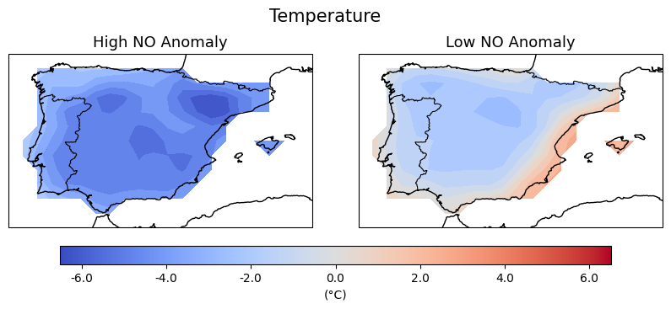 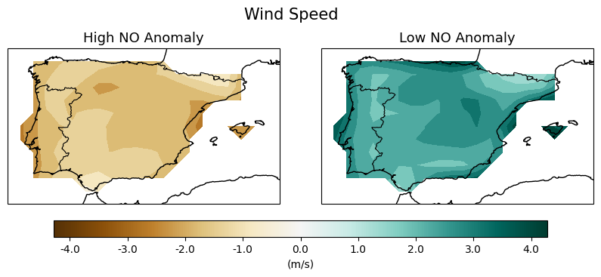

Appendix X –

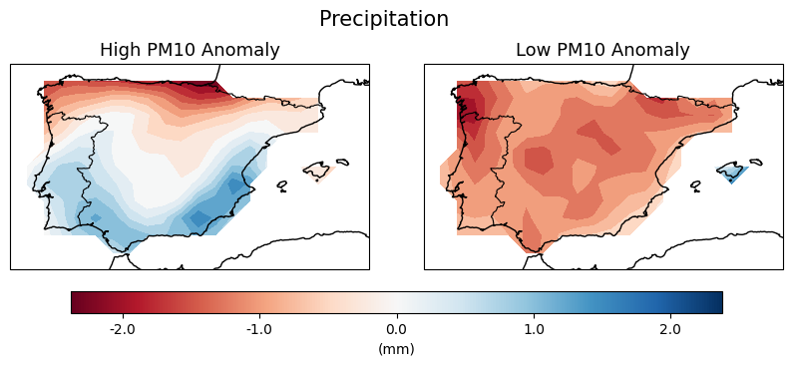 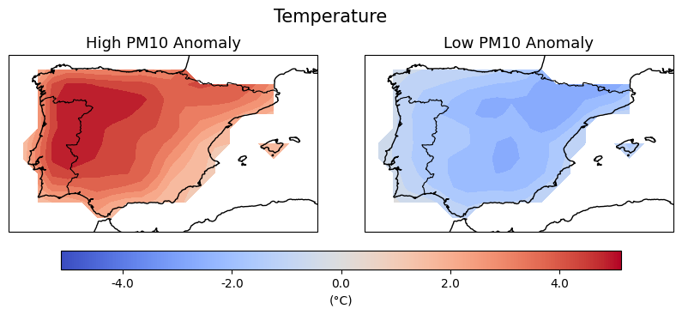 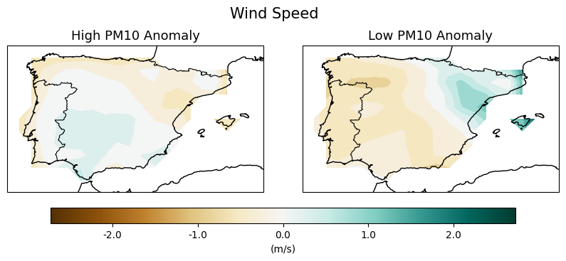

Appendix X -

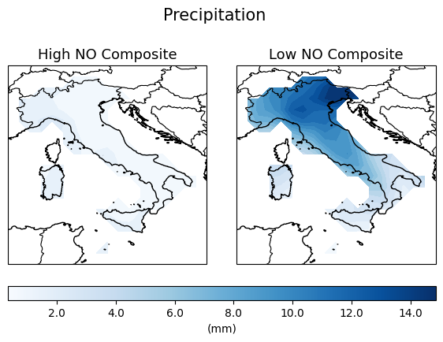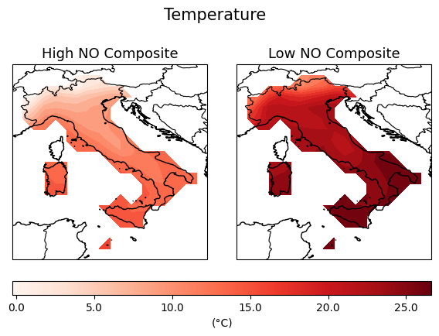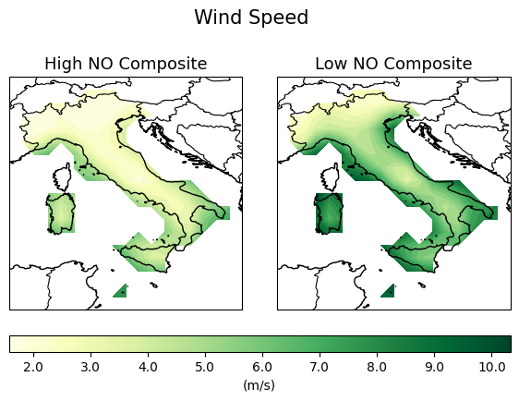

Appendix X -

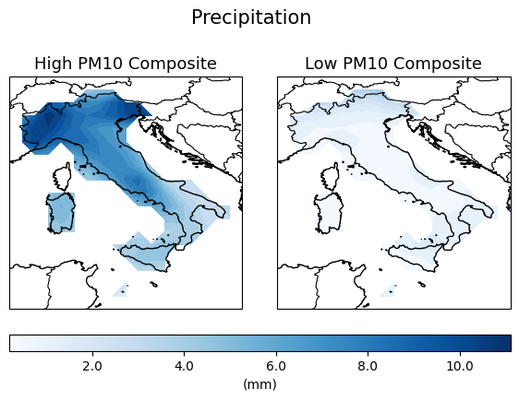 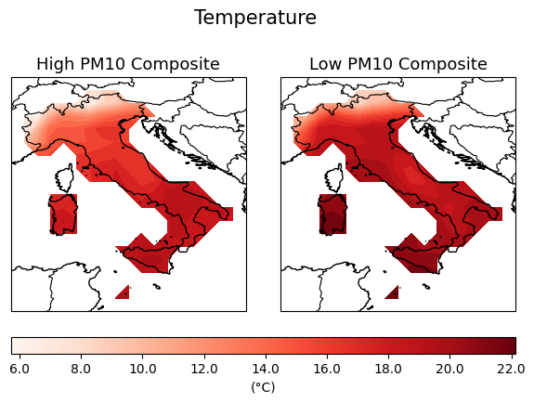 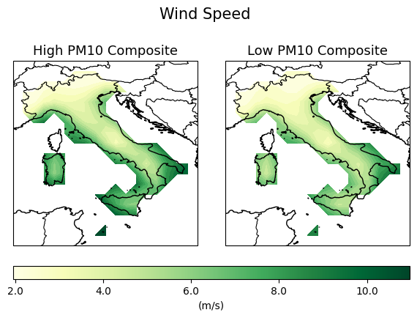

Appendix X -

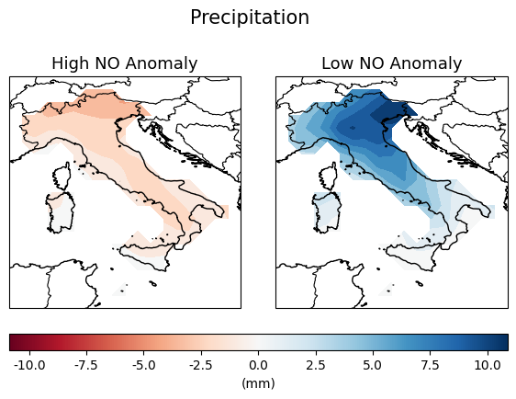 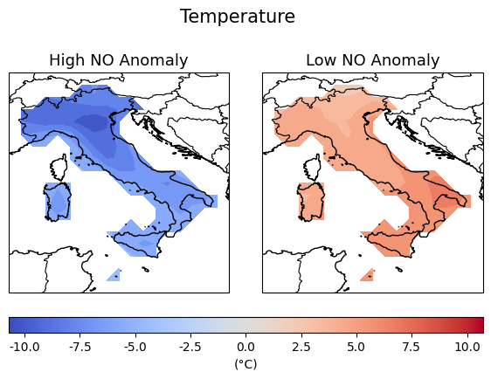 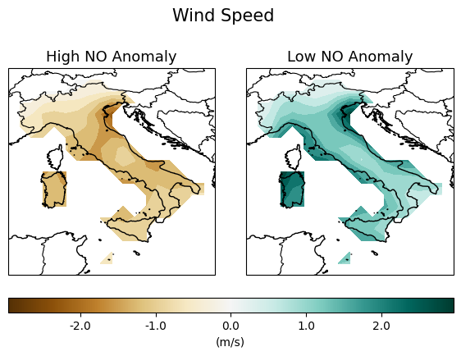

Appendix X -

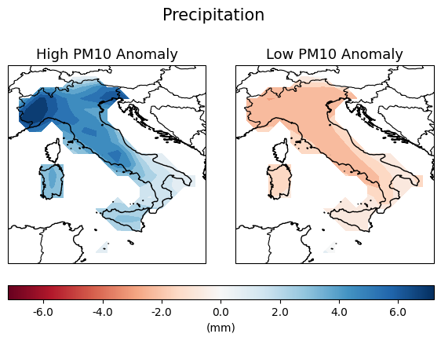 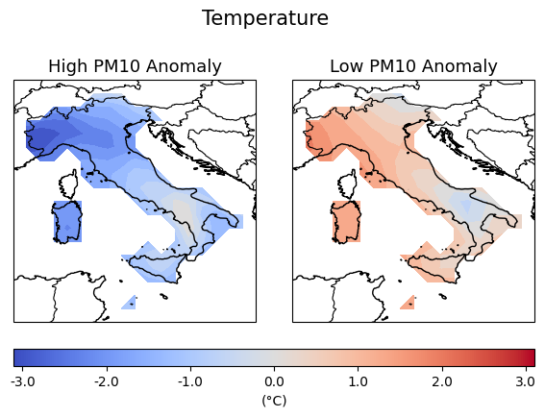 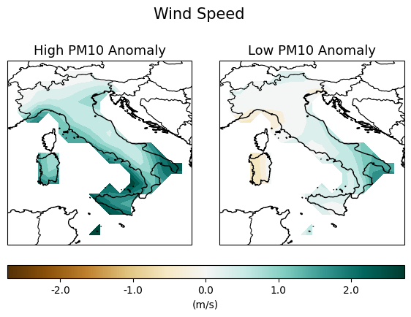

Appendix X -

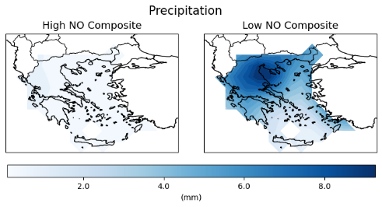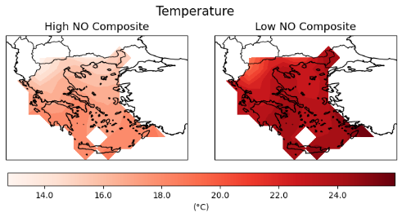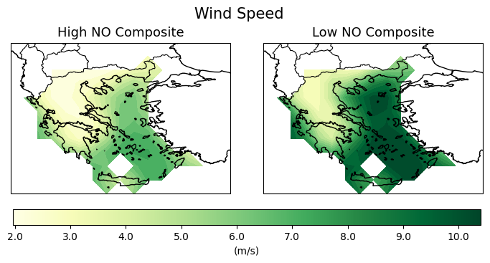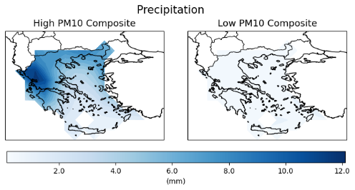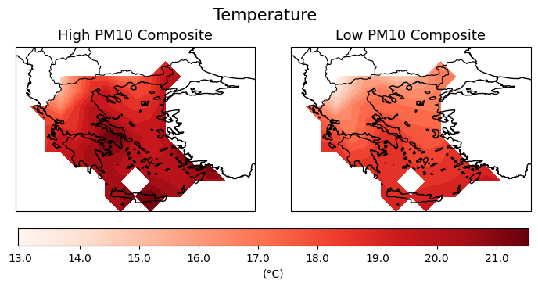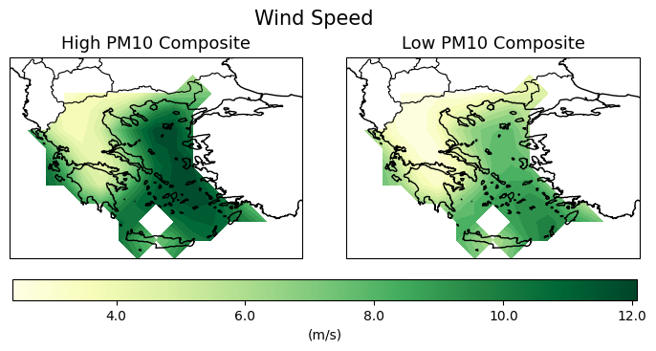

Appendix X -

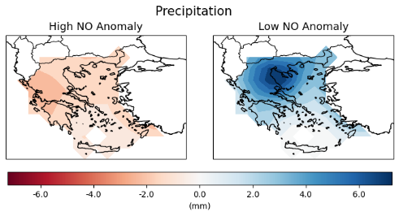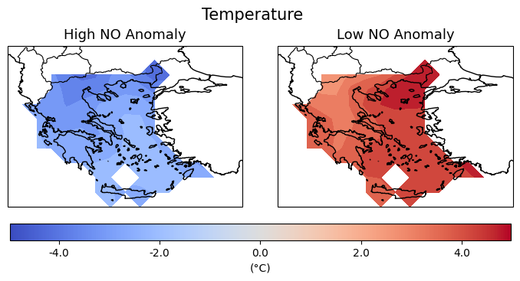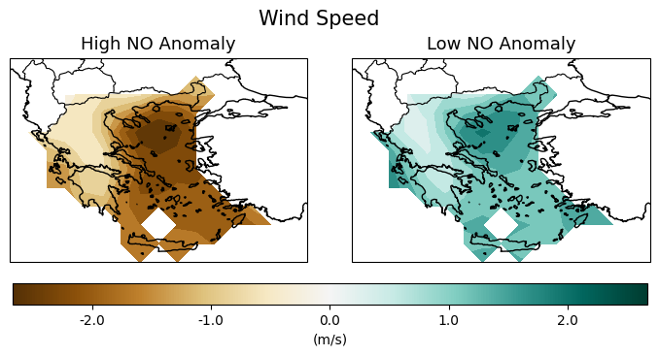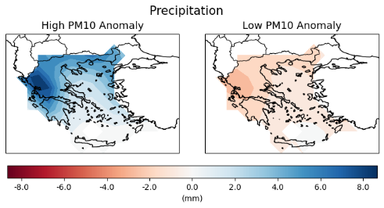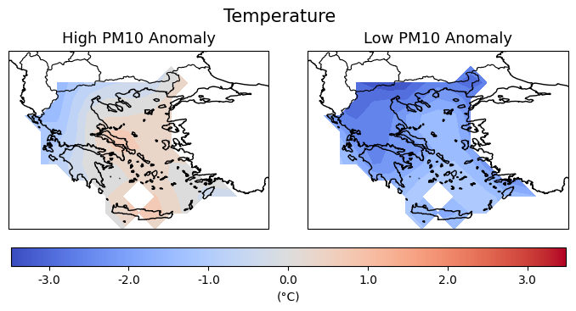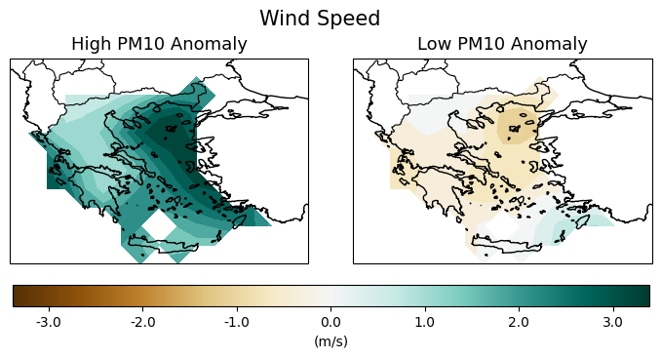

3.5.2.Nitrogen Monoxide (NO) - Appendix

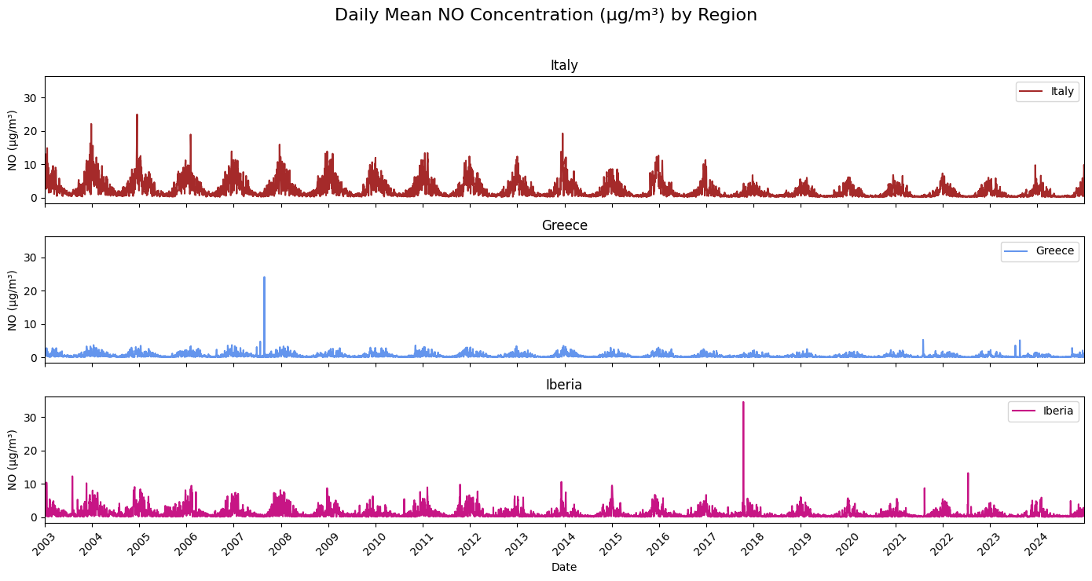

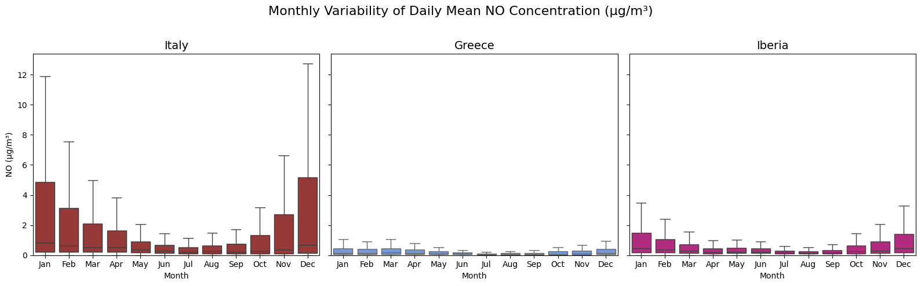

3.5.2.Particulate Matter d < 10 μm (PM10) - Appendix

